Telusko: Advance Java 10

226 SpringSecurity (Basic Authentication and SpringBoot with JDBC Authentication) Live Class

Topics
a. SpringSecurity(All levels of Authentication and authorization:: 3 classes)
b. Junit(1 class)
c. HttpUnit with Mockito(1 class)
d. React and SpringBoot Integration(2 classes)
e. JDBC app development using type-1,type-2,type-3 driver(deprecated: one class)
e. Docker and K8s ( by other trainer -> Already started.)
SpringBoot Modules
a.SpringCore
b.SpringDataJPA
c.SpringMVC
d.SpringAOP
e.SpringRest
f.SpringJMS(SpringMail)
g.SpringSecurity
SpringSecurity
-> Pre-requisite :
CoreJava,Servlet,JSP,SpringCore,SpringDataJPA,SpringMVC,SpringRest.
SpringBoot Security
=> It is a Spring extension module that provides enable security on SpringBoot MVC and SpringRest applications.
mulitple ready made filter to
Note:
If we make filter component as a SpringBean IOC container then any othe dependent
spring bean object can be injected to that Servlet Filter
SpringBean,but that servlet filter cannot trap the request from the browser
window.
For this we need configure special ready made servlet filter component given by
SpringSecurity module called "DelegationFilterProxy" having
URL Pattern "/",with logical name matching with ServletFilter component bean id.
How to Secure our RestAPI's using SpringBoot?
=> Security is most important for webapplication.
=> To protect our application and application data we need to implement security.
=> To provide security for webapplication and restful api's spring framework had
given a seperate module called "Spring-Security".
Create a SpringRest project with the following dependancies
a. SpringWeb
b. SpringSecurity
c. DevTools
To secure our Restapi's we need to add the following dependancy in pom.xml file
<dependency>
<groupId>org.springframework.boot</groupId>
<artifactId>spring-boot-starter-security</artifactId>
</dependency>
=> When we add this dependancy our application will be secured with "Basic
Authentication".
=> To access the endpoints we need to login to the application with the following
credentials
username : user
password : <copy from the console>
+++++++++++++++++++++++BankRestController.java
+++++++++++++++++++++++
package in.ineuron.nitin.restcontroller;
import org.springframework.web.bind.annotation.GetMapping;
import org.springframework.web.bind.annotation.RestController;
@RestController
public class BankRestController {
@GetMapping("/")
public String welcomePage() {
return "Welcome to ICICI Bank";
}
}
browser
+++++++
request : GET -> http://localhost:9999/
response : It will be redirected to http://localhost:9999/login
username : user
password : 95e4ce5c-9bdc-4909-ac3e-cb1985b30ce5(copied from
console after running the application)
Welcome to ICICI Bank
POSTMAN
+++++++
request : GET -> http://localhost:9999/bank/
response : It generates the response as 401(Unauthorized access)
Go to authorization model in postman
username : user
password : 95e4ce5c-9bdc-4909-ac3e-cb1985b30ce5(copied from
console after running the application)
click on send button
response : Welcome to ICICI Bank
Note:
Q> The default password generated by the application is not userfriendly, if we
want to override the credentials it is possible?
answer: yes it is possible, to do so we need to use "application.properties".
application.properties
server.port = 9999
spring.security.user.name=root
spring.security.user.password=root123
Now if we start the application, SpringRest will not genreate the default password.
browser
+++++++
request : GET -> http://localhost:9999/bank/
response : It will be redirected to http://localhost:9999/login
username : root
password : root123
Welcome to ICICI Bank
POSTMAN
+++++++request : GET -> http://localhost:9999/bank/
response : It will be redirected to http://localhost:9999/login
Go to authorization model in postman
username : root
password : root123
click on send button
response : Welcome to ICICI Bank(200 ok)
response : It will be redirected to http://localhost:9999/login
Go to authorization model in postman
username : root
password : root123#113
click on send button
response : 401(unAuthorized Access)
+++++++++++++++++++++++++++++++++++++++++++++++
Restricting the authroization for few ENDPOINTS
+++++++++++++++++++++++++++++++++++++++++++++++
@GetMapping("/transfer")
public String fundTransfer() {
return "Fund transfer initiated";
}
@GetMapping("/balance")
public String checkBalance() {
return "Balance amount is :: 10000INR";
}
@GetMapping("/about")
public String aboutUs() {
return "ICICI bank is managed by India Central Govt";
}
request : http://localhost:9999/bank/transfer/
request : http://localhost:9999/bank/balance/
request : http://localhost:9999/bank/about/
All the endpoints mentioned above will be authenticated, but in realtime only few
endpoints should be authenticated but not all.
eg: SBI application
/about us -> not authentication
/fundtransfer -> authentication is required(login is required)
/balance -> authentication is required(login is required)
In our application,by default all the endpoints are authenticated, if we want to
authenticate few endpoints then we need to for customzation.
To secure our own URL patterns, we need to use "SecurityConfiguration" as shown
below.
package in.ineuron.nitin.securityconfiguration;
import org.springframework.context.annotation.Bean;
import org.springframework.context.annotation.Configuration;
import org.springframework.security.config.annotation.web.builders.HttpSecurity;
import
org.springframework.security.config.annotation.web.configuration.EnableWebSecurity;
import org.springframework.security.web.SecurityFilterChain;
@Configuration
@EnableWebSecurity
public class SecurityConfigApp {@Bean
Exception {
public SecurityFilterChain userDefinedFilter(HttpSecurity http) throws
http.authorizeHttpRequests(
request -> request.antMatchers("/bank/", "/login",
"/bank/about")
.permitAll()
.anyRequest()
.authenticated())
.formLogin();
return http.build();
}
}
output
request : http://localhost:9999/bank/
response : Welcome to ICICI Bank
request :http://loclahost:9999/bank/transfer
response :It will be redirected to http://localhost:9999/login
Go to authorization model in postman
username : root
password : root123
click on send button
response : Fund transfer initiated
request :http://loclahost:9999/bank/balance
response : It will be redirected to http://localhost:9999/login
Go to authorization model in postman
username : root
password : root123
click on send button
response : Balance amount is :: 10000INR
request : http://loclahost:9999/bank/about
response : ICICI bank is managed by India Central Govt
Note: If the credentials supplied by the user is wrong, then it will be redirected
to "http://localhost:9999/login?error"[Bad Credentials]
In the above application, the credentials information is hardcoded inside
application.properties file,but in reality the credentials information will
be stored in the database. To do so we need to use "SpringSecurity with JDBC
authentication".
+++++++++++++++++++++++++++++++++++++++
SpringSecurity with JDBC authentication
+++++++++++++++++++++++++++++++++++++++
1. Create a Springstarter project with the following dependancies
a. SpringDev tools
b. MySQLDriver
c. Spring Data JDBC
d. SpringSecurity
e. SpringWeb
2. application.properties
server.port = 9999
spring.datasource.url =jdbc:mysql://localhost:3306/enterprisejava
spring.datasource.username= rootspring.datasource.password= root123
3. Create a REST endpoints as shown below
package in.ineuron.nitin.restcontroller;
import org.springframework.web.bind.annotation.GetMapping;
import org.springframework.web.bind.annotation.RequestMapping;
import org.springframework.web.bind.annotation.RestController;
@RestController
@RequestMapping("/api")
public class UserRestController {
@GetMapping("/")
public String welcome() {
return "<h1>Welcome to iNeuron Family</h1>";
}
@GetMapping("/admin")
public String adminProcess() {
return "<h1>Welcome Admin</h1>";
}
@GetMapping("/user")
public String userProcess() {
return "<h1>Welcome User</h1>";
}
}
4. Create a CustomConfigation for handling the RestEndPoints.
package in.ineuron.nitin.securitfyconfiguration;
import javax.sql.DataSource;
import org.springframework.beans.factory.annotation.Autowired;
import org.springframework.context.annotation.Bean;
import org.springframework.context.annotation.Configuration;
import
org.springframework.security.config.annotation.authentication.builders.Authenticati
onManagerBuilder;
import org.springframework.security.config.annotation.web.builders.HttpSecurity;
import
org.springframework.security.config.annotation.web.configuration.EnableWebSecurity;
import org.springframework.security.crypto.bcrypt.BCryptPasswordEncoder;
import org.springframework.security.web.SecurityFilterChain;
@Configuration
@EnableWebSecurity
public class SecurityConfigApp {
@Autowired
private DataSource dataSource;
@Autowired
Exception {
public void authenticationManager(AuthenticationManagerBuilder auth) throwsauth
.jdbcAuthentication()
.passwordEncoder(new BCryptPasswordEncoder())
.dataSource(dataSource)
.usersByUsernameQuery("select username,password,enabled from users
where username =?")
.authoritiesByUsernameQuery("select username,authority from authorities
where username=?");
}
@Bean
Exception {
public SecurityFilterChain customFilterChain(HttpSecurity http) throws
http.authorizeHttpRequests(
request -> request.antMatchers("/api/").permitAll()
.antMatchers("/api/admin/").hasRole("ADMIN")
.antMatchers("/api/user/").hasAnyRole("ADMIN","USER")
.anyRequest().authenticated()
).formLogin();
return http.build();
}
}
Run the application and send the request
request : http://localhost:9999/api/
response : Welcome to iNeuron Family
request :http://localhost:9999/api/admin
response : It will redirected to http://localhost:9999/login
username : sachin
password : sachin@123
response : Welcome Admin
request :http://localhost:9999/api/user
response : It will redirected to http://localhost:9999/user
username : gill
password : gill@123
response : Welcome User
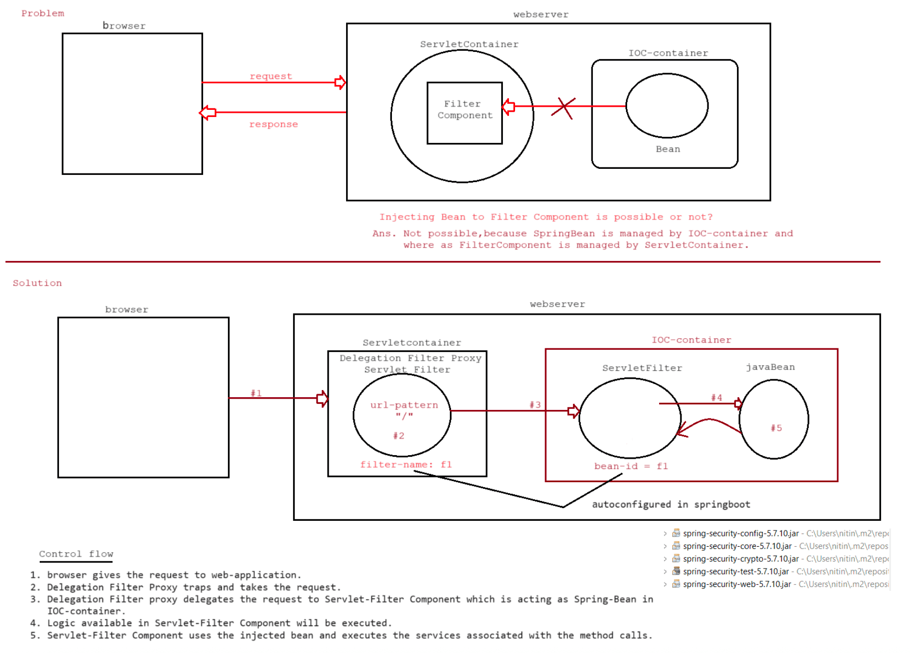
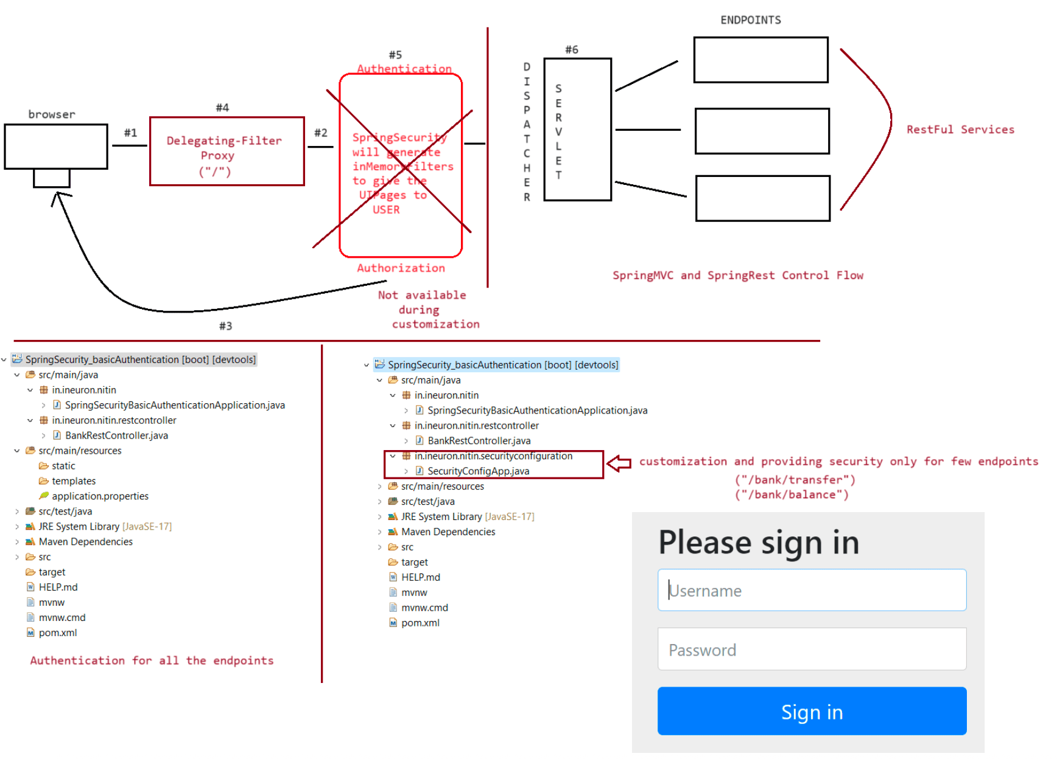
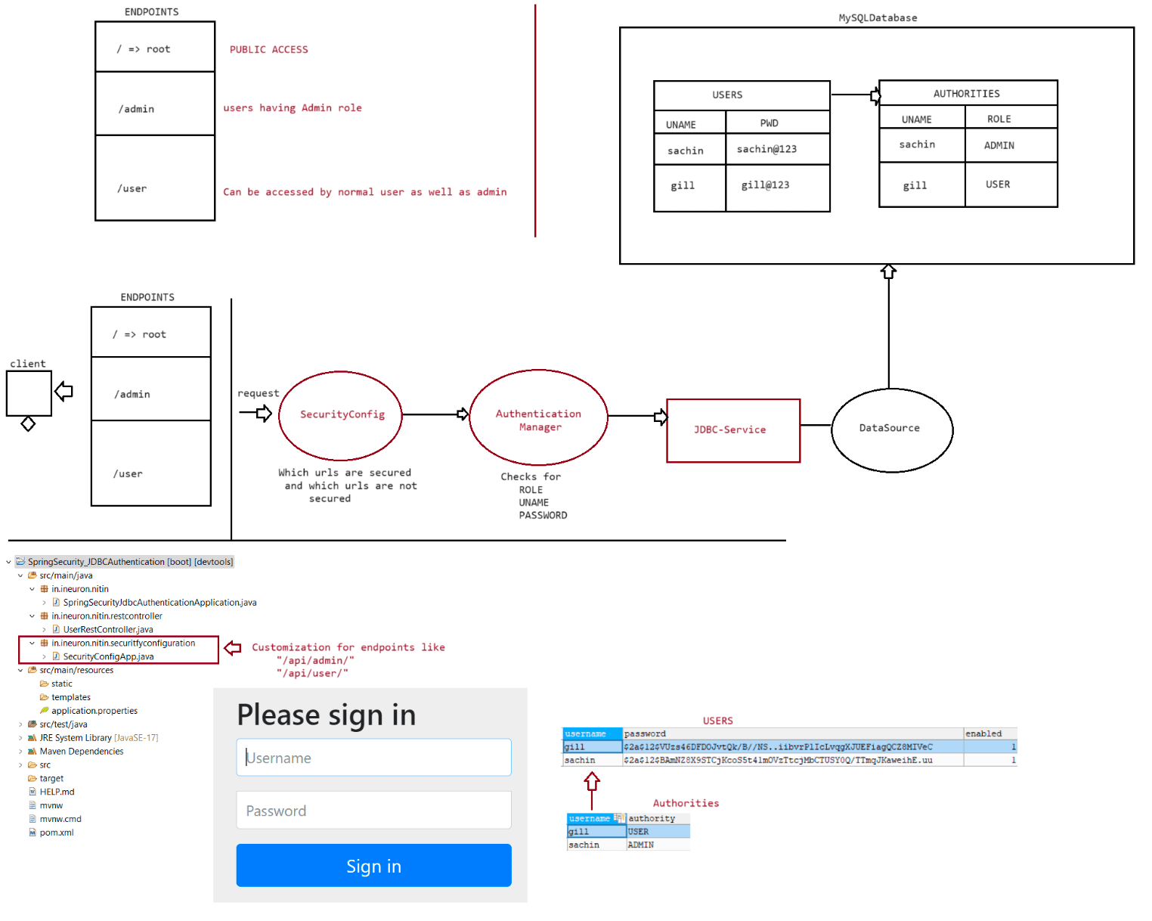

227 SpringSecurity Inmemory authentication and SpringSecurity using OAuth2 Live Class

Working with webapplication to use SpringSecurity
+++++++++++++++++++++++++++++++++++++++++++++++++
Deciding the authentication and authorization levels for different request url
/ => permitAll()
/offers => authenticated() [only authentication]
/balance => authenticated() + Authorization() ::
hasAnyRoles("CUSTOMER","MANAGER")
/loan => authenticated() + Authorization() :: hasRole("MANAGER")
1. Create a project with the following dependencies
a. springsecurity
b. spring web
c. spring devtools
d. embeded jasper
2. Create the end points as shown below
BankOperationController.java
++++++++++++++++++++++++++++
package in.ineuron.nitin.controller;
import org.springframework.stereotype.Controller;
import org.springframework.web.bind.annotation.GetMapping;
@Controller
public class BankOperationController {
@GetMapping("/")
public String showHome() {
return "home";
}
@GetMapping("/offers")
public String showOffers() {
return "offers";
}
@GetMapping("/balance")
public String checkBalance() {
return "show_balance";
}
@GetMapping("/loanApprove")
public String approveLoan() {
return "loan";
}
@GetMapping("/denied")
public String accessDenied() {
return "access_denied";
}
}
3. application.properties
#server port
server.port = 9999
#View resolver configurationspring.mvc.view.prefix= /WEB-INF/pages/
spring.mvc.view.suffix=.jsp
4. View component
home.jsp
++++++++
<%@ page language="java" contentType="text/html; charset=ISO-8859-1"
pageEncoding="ISO-8859-1"%>
<!DOCTYPE html>
<html>
<head>
<meta charset="ISO-8859-1">
<title>HomePage</title>
</head>
<body>
<h1 style='color: red; text-align: center'>Welcome to SBI-Bank
---- Home Page</h1>
<a href='balance'>Check Balance</a>
<br /><br/>
<a href='loanApprove'>Approve Loan</a>
<br /><br/>
<a href='offers'>Offers</a>
</body>
</html>
offers.jsp
+++++++++
<%@ page language="java" contentType="text/html; charset=ISO-8859-1"
pageEncoding="ISO-8859-1"%>
<!DOCTYPE html>
<html>
<head>
<meta charset="ISO-8859-1">
<title>OFFER PAGe</title>
</head>
<body>
<h1 style='color:blue;text-align: center'>
SHOW OFFER PAGE
</h1>
<pre>
HOME LOAN ROI : 7% <br/>
FOURWHEELER LOAN ROI : 8% <br/>
PERSONAL LOAN ROI : 12% <br/>
</pre>
<a href='./'>HOME</a>
</body>
</html>
loan.jsp
++++++++
<%@page import="java.util.Random"%>
<%@ page language="java" contentType="text/html; charset=ISO-8859-1"
pageEncoding="ISO-8859-1"%>
<!DOCTYPE html>
<html>
<head>
<meta charset="ISO-8859-1"><title>Loan Amount</title>
</head>
<body>
<h1 style="color: blue; text-align: center;">LOAN APPROVAL PAGE</h1>
<pre>
<b> U r approved for a loan amount :: <%=new
Random().nextInt(100000)%></b>
<a href="./">HOME</a>
</pre>
</body>
</html>
show_balance.jsp
++++++++++++++++
<%@ page language="java" contentType="text/html; charset=ISO-8859-1"
pageEncoding="ISO-8859-1" import="java.util.Random"%>
<!DOCTYPE html>
<html>
<head>
<meta charset="ISO-8859-1">
<title>SHOW BALANCE</title>
</head>
<body>
<h1 style='color:blue;text-align: center'>SHOW BALANCE PAGE</h1>
<b>
BALANCE :: <%= new Random().nextInt(10000000) %>
</b>
</body>
</html>
access_denied.jsp
+++++++++++++++++
<%@page import="org.springframework.security.core.context.SecurityContextHolder"%>
<%@ page language="java" contentType="text/html; charset=ISO-8859-1"
pageEncoding="ISO-8859-1"%>
<!DOCTYPE html>
<html>
<head>
<meta charset="ISO-8859-1">
<title>INVALID USER PAGE</title>
</head>
<body>
<h1 style='color: red; text-align: cener'>
Authorisation Failed for
<%=SecurityContextHolder.getContext().getAuthentication().getName()%>
</h1>
<br/>
<a href="./">HOME</a>
</body>
</html>
5. Customizing the ENDPONITS with Authentication and AuthorizationSecurityConfigApp.java
++++++++++++++++++++++
package in.ineuron.nitin.securityconfiguration;
import org.springframework.beans.factory.annotation.Autowired;
import org.springframework.context.annotation.Bean;
import org.springframework.context.annotation.Configuration;
import
org.springframework.security.config.annotation.authentication.builders.Authenticati
onManagerBuilder;
import org.springframework.security.config.annotation.web.builders.HttpSecurity;
import
org.springframework.security.config.annotation.web.configuration.EnableWebSecurity;
import org.springframework.security.web.SecurityFilterChain;
@Configuration
@EnableWebSecurity
public class SecurityConfigApp {
@Autowired
Exception {
public void configureAuthorities(AuthenticationManagerBuilder auth) throws
// {noop} -> No Encoded Password indication
auth.inMemoryAuthentication().withUser("sachin").password("{noop}tendulkar").roles(
"CUSTOMER");
auth.inMemoryAuthentication().withUser("ramesh").password("{noop}mumbai").roles("MA
NAGER");
}
@Bean
public SecurityFilterChain configure(HttpSecurity http) throws Exception {
// authorize requests(HTTP)
http.authorizeHttpRequests().antMatchers("/").permitAll().antMatchers("/
offers").authenticated()
.antMatchers("/balance").hasAnyRole("CUSTOMER",
"MANAGER").antMatchers("/loanApprove")
.hasRole("MANAGER").anyRequest().authenticated().and().http
Basic().and().exceptionHandling()
.accessDeniedPage("/denied");
return http.build();
}
}
Scenario1::
request : http://localhost:9999/
response : home.jsp will be rendered to display the services of bank
Scenario2::
request : http://localhost:9999/
response : home.jsp page(upon clicking offer link)
it will redirect to login
username : user
password : copy from the consoleit displays offer.jsp page
Scenario3::
request : http::/localhost:9999
response : home.jsp page(upon clikcing show_balance link)
it will redirect to login
username : sachin
password : tendulkar
it displays show_balance.jsp
Scenario4::
request : http::/localhost:9999
response : home.jsp page(upon clicking Approve Loan link)
it will redirect to login
username : ramesh
password : mumbai
it displays loan.jsp
During the execution if any exception occurs like entering wrong username or wrong
password it would redirect to "access_denied.jsp" page.
Limitations of Basic Mode Authentication
1. Dialog box asks for username and password,but it can't be customzied
2. It doesn't allow the features like
a. logout b. remember me c. SessionMaxActiveCount Limit ....
To resolve this problem we need to go for
a. httpBasic() -> gives basic mode of Authentication
b. formLogin() -> gives FORM mode of Authentication.
Another filter
a. and().rememberMe()
=> It adds another filter called "Remember Me Authentication".
=> Internally it uses persistent cookies to remember the given username
and password with "48 hours expiry time".
=> In this 48 hours after succesful login, if u close the browser by
the taking the url from browser address bar and again if
we login we can use the same URL to get bak the page without
performing signin activity.
b. and().logout()
=> It adds another filter called Logout".
=> it helps us to provide signup activity having the url with request
path "/logout" by defualt.
c. and().sessionManagement().maximumSession(2).maxSessionPreventsLogin(true)
=> it adds another filter to control the no of sessions for each user
to operate the application.
Session
If login is successfull it creates a session
HttpSession session = request.getSession(true)
To access the existing session
HttpSession session =request.getSession(false)
To stop the seesion
session.invalidate()To specify the maxinactive interval period of session
session.maxInactiveInterval(20)
++++++++++++++++++++++++++++++++++++++
Adding extra filters to our application
+++++++++++++++++++++++++++++++++++++++
package in.ineuron.nitin.securityconfiguration;
import org.springframework.beans.factory.annotation.Autowired;
import org.springframework.context.annotation.Bean;
import org.springframework.context.annotation.Configuration;
import
org.springframework.security.config.annotation.authentication.builders.Authenticati
onManagerBuilder;
import org.springframework.security.config.annotation.web.builders.HttpSecurity;
import
org.springframework.security.config.annotation.web.configuration.EnableWebSecurity;
import org.springframework.security.web.SecurityFilterChain;
@Configuration
@EnableWebSecurity
public class SecurityConfigApp {
@Autowired
Exception {
public void configureAuthorities(AuthenticationManagerBuilder auth) throws
//Authorization -> Roles of the user
// {noop} -> No Encoded Password indication
auth.inMemoryAuthentication().withUser("sachin").password("{noop}tendulkar").roles(
"CUSTOMER");
auth.inMemoryAuthentication().withUser("ramesh").password("{noop}mumbai").roles("MA
NAGER");
}
@Bean
public SecurityFilterChain configure(HttpSecurity http) throws Exception {
// authorize requests(HTTP)
http.authorizeHttpRequests().antMatchers("/").permitAll().antMatchers("/
offers").authenticated()
.antMatchers("/balance").hasAnyRole("CUSTOMER",
"MANAGER").antMatchers("/loanApprove")
.hasRole("MANAGER").anyRequest().authenticated().and().form
Login().and().rememberMe().and().logout()
.and().exceptionHandling().accessDeniedPage("/denied").and().sessionManagement().ma
ximumSessions(2)
.maxSessionsPreventsLogin(true);
return http.build();
}
}
+++++++++++++++++++++++Working with Outh login
+++++++++++++++++++++++
Github credentials
username :: kallepallychandrakiran@gmail.com
password :: Kiran@019
Create a Project with the following depenancies
a. SpringDevTools
b. SpringSecurity
c. SpringWeb
d. OAuth2 Client
2. Create a Rest Controller with Endpoint("/")
package in.ineuron.nitin.restcontroller;
import org.springframework.web.bind.annotation.GetMapping;
import org.springframework.web.bind.annotation.RestController;
@RestController
public class WelcomeRestController {
@GetMapping("/")
public String welcome() {
return "Welcome to iNeuron Family";
}
}
3. Since the Github website is used for Redirection to our application we need to
1. login to github(with valid credentials)
2. Go to settings
3. Go to public -> scroll down search for developer settings
4. Give the following details
Application name :: Springboot_secured_rest_api
Homepage URL :: http://localhost:9999/
Authorization callback URL :: http://localhost:9999/
Observe the client id :: b5057999f859ff279974
click on generate the token::
1edbd8d501fc0b16886dd3e3b44c4f20700a0baf
4. Configure the properties file our application with the token generated by
"Github" for the respective endpoints("/")
application.yml
+++++++++++++++
server:
port: 9999
spring:
security:
oauth2:
client:
registration:
github:
clientId: b5057999f859ff279974
clientSecret: 1edbd8d501fc0b16886dd3e3b44c4f20700a0baf
5. Now run the application and send the request to
request : http://localhost:9999/
response : redirected to github login pageusername : <valid username>
password : <valid password>
click on login
response : Welcome to iNeuron Family

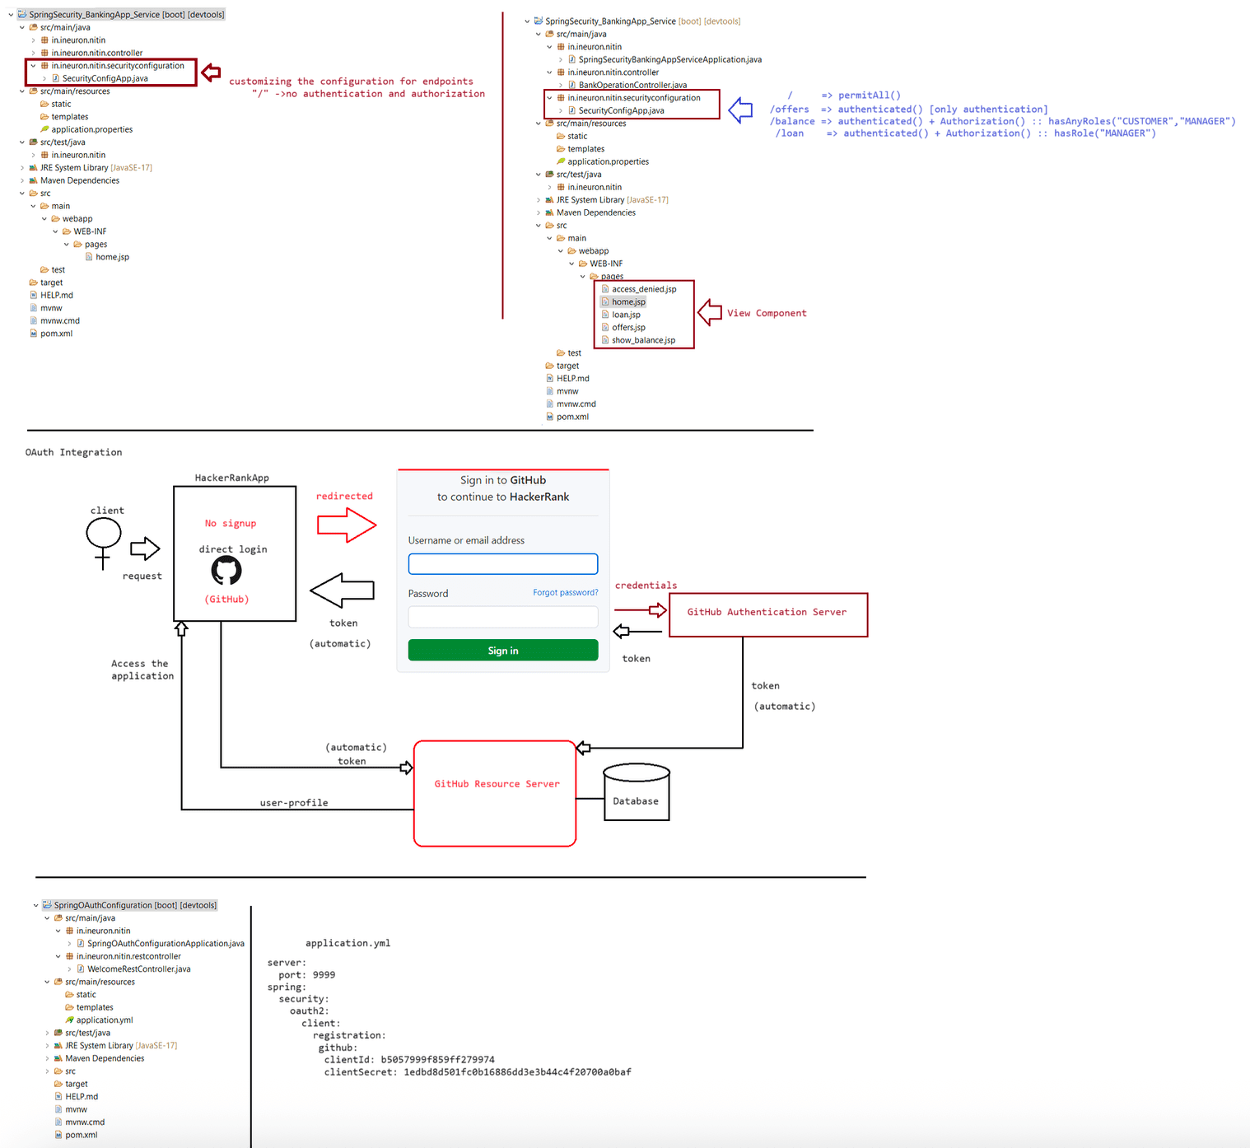

228 SpringSecurity using DataJPA(registration for users and performing authentication by customizing the page) Live Class

+++++++++++++++++++++++++++++++++
SpringSecurity with SpringDataJPA
+++++++++++++++++++++++++++++++++
=> There is no direct provision to work with SpringData JPA or Spring ORM based
authentication info provider, so we need to implement most of
the logic manually as we do in other spring boot layer apps by taking seperate
repository interfaces, service classes,model classes etc....
eg: auth.inMemoryAuthentication(), auth.jdbcAuthentication() like this there
is no direct template to work with SpringDataJPA(ORM)
based authentication provider.
=> userregistration page(thymleaf)
BCryptPasswordEncoder
|
formpage ----> DS ----> Controller ----pwd----> Service --EncodedPwd---->
Repository ------> DB S/w
(Security)
1. Create a project using the following starters
a. thymleaf starter
b. mysql-driver
c. springdatajpa
d. spring web
e. spring security
Note: From Maven repository download the following dependancy and add it to pom.xml
file
<dependency>
<groupId>org.thymeleaf.extras</groupId>
<artifactId>thymeleaf-extras-springsecurity5</artifactId>
</dependency>
2. Create a model class as shown below
@Table(name = "SECURITY_USERS")
@Entity
@Data
public class UserDetails {
@GeneratedValue(strategy = GenerationType.IDENTITY)
@Id
private Integer uid;
@Column(length = 20, unique = true, nullable = false)
private String uname;
@Column(length = 20, unique = true, nullable = false)
private String pwd;
@Column(length = 20, unique = true, nullable = false)
private String email;
private boolean status = true;
@ElementCollection(fetch = FetchType.EAGER)
@CollectionTable(name = "SECURITY_ROLES", joinColumns = @JoinColumn(name =
"USER_ID", referencedColumnName = "uid"))
@Column(name = "role")private Set<String> roles;
}
3. Create userregistration.html to take the inputs from the user
+++++++++++++++++++++
user_registration.html
++++++++++++++++++++++
<html xmlns:th="https://thymeleaf.org">
<form th:action="@{/user/register}" th:object="${userInfo}" method="POST">
<table border="0" bgcolor="cyan" align="center">
<tr>
<td> username :: </td>
<td> <input type="text" th:field="*{uname}" /> </td>
</tr>
<tr>
<td> password :: </td>
<td> <input type="password" th:field="*{pwd}" /> </td>
</tr>
<tr>
<td> email :: </td>
<td> <input type="text" th:field="*{email}" /> </td>
</tr>
<tr>
checked > CUSTOMER
MANAGER
<td> Roles: </td>
<td> <input type="checkbox" th:field="*{roles}" value="CUSTOMER"
<input type="checkbox" th:field="*{roles}" value="MANAGER" >
</td>
</tr>
<tr>
<td> <input type="submit" value="register"> </td>
<td> <input type="reset" value="cancel"> </td>
</tr>
</table>
</form>
4. set up the application.properties file with the following key-value pair data
++++++++++++++++++++++
application.properties
++++++++++++++++++++++
spring.datasource.driver-class-name=com.mysql.cj.jdbc.Driver
spring.datasource.url=jdbc:mysql://localhost:3306/octbatch
spring.datasource.username=root
spring.datasource.password = root123
spring.jpa.show-sql=true
spring.jpa.hibernate.ddl-auto=update
spring.jpa.database-platform=org.hibernate.dialect.MySQL8Dialect
spring.jpa.properties.hibernate.format_sql =true
5. Create a ENDPOINTS to collect the value from the user, upon loading the page
+++++++++++++++++++
UserController.java
+++++++++++++++++++@Controller
@RequestMapping("/user")
public class UserController {
@Autowired
private IUserService service;
@GetMapping("/register")//for loading the page
public String showRegistrationPage(@ModelAttribute("userInfo") UserDetails
details) {
System.out.println("UserController.showRegistrationPage()");
return "user_register";
}
@PostMapping("/register")//for submitting the page with loaded values
public String registerUser(@ModelAttribute("userInfo") UserDetails details,
Map<String, Object> map) {
System.out.println("UserController.registerUser()");
String resultMsg = service.regsiter(details);
map.put("message", resultMsg);
return "user_registerd_success";
}
}
6. Create a Service layer as shown below(Provide Encryption also)
+++++++++++++++++
IUserService.java
+++++++++++++++++
package in.ineuron.nitin.service;
import org.springframework.security.core.userdetails.UserDetailsService;
import in.ineuron.nitin.model.UserDetails;
public interface IUserService extends UserDetailsService{
public String regsiter(UserDetails details);
}
++++++++++++++++++++
UserServiceImpl.java
++++++++++++++++++++
package in.ineuron.nitin.service;
import org.springframework.beans.factory.annotation.Autowired;
import org.springframework.security.core.userdetails.UserDetails;
import org.springframework.security.core.userdetails.UsernameNotFoundException;
import org.springframework.security.crypto.bcrypt.BCryptPasswordEncoder;
import org.springframework.stereotype.Service;
import in.ineuron.nitin.repository.IUserDetailsRepo;
@Service("userService")
public class UserServiceImpl implements IUserService {
@Autowiredprivate IUserDetailsRepo repo;
@Autowired
private BCryptPasswordEncoder encoder;
@Override
public UserDetails loadUserByUsername(String username) throws
UsernameNotFoundException {
System.out.println("UserServiceImpl.loadUserByUsername()");
return null;
}
@Override
public String regsiter(in.ineuron.nitin.model.UserDetails details) {
System.out.println("UserServiceImpl.regsiter()");
details.setPwd(encoder.encode(details.getPwd()));
return repo.save(details).getUid() + " UserId is registered";
}
}
7. Create html to display the success data
++++++++++++++++++++++++++++
user_registered_success.html
++++++++++++++++++++++++++++
<html xmlns:th="https://thymeleaf.org">
<b>hello</b>
<h1 style="color:green;text-align:center"><span th:text="${message}" /> </h1>
<br>
<b><a th:href="@{/user/register}">Add another user</a></b>
+++++++++++++++++++++++++++++++++++++++++++++++++++++++++++++++++++++++++++++++++++
++++++++++++++++++++++++
Adding the custom login page to the project to perform authentication and
authorization using SpringDataJPA
+++++++++++++++++++++++++++++++++++++++++++++++++++++++++++++++++++++++++++++++++++
++++++++++++++++++++++++
Control flow
a. POST + /login
=> request springboot security app
=> Security Config class sends the data to loadUserByUsername(String
username) method of UserDetailsService class.
1. Different URLS
/login + GET => Default authentication form based for authentication login
page.
/login + POST => To process default form based authentication login page
submission
2. Adding handlerMethods to process the custom login page
@RequestMapping("/showLogin")
public String showLoginPage() {
return "custom_login";
}JWT and Gmail,Facebook authentication
Sunday-> Junit,HttpUnit and mockito

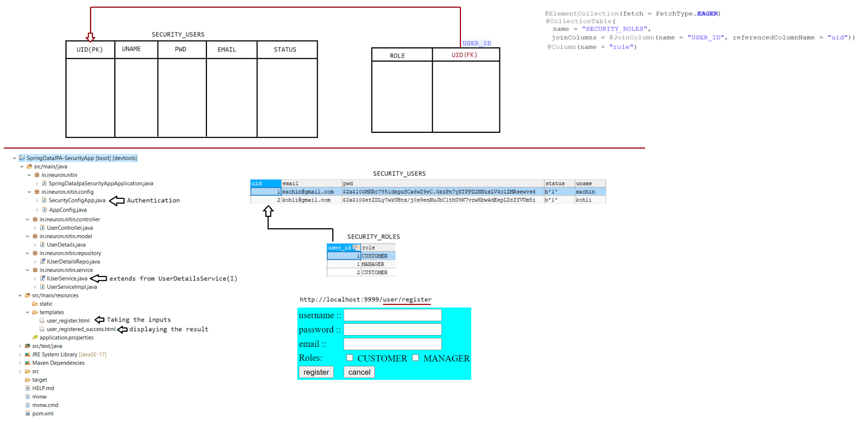

229 SpringSecurity for Authentication and Authorization for Webapp's using DataJPA, SpringOauthAuthentication using Facebook login for RestApi's Live Class

+++++++++++++++++++++++++++++++++++++++++++++++++++++++++++++++++++++++++++++++++++
++++++++++++++++++++++++
Adding the custom login page to the project to perform authentication and
authorization using SpringDataJPA
+++++++++++++++++++++++++++++++++++++++++++++++++++++++++++++++++++++++++++++++++++
++++++++++++++++++++++++
=> Here we need to configure service class that implements an inbuilt spring
security supplied interface called
"org.springframework.security.core.userdetails.UserDetailsService".
=> When we give /login+POST request to spring security app, the security config
class sends the request to loadUserByUsername() method of the above service class.
=> loadUserByUsername() method would return
"org.springframework.security.core.userdetails.User" object that implments
"org.springframework.security.core.userdetails.UserDetails" which holds the
current user logged in details like username,password,roles etc.
=> org.springframework.security.core.userdetails.User will be given to
SecurityConfig class for validation/verifcation purpose.
=> if the verification is succesfull it keeps the login details in "HttpSession"
and show defaultSuccessUrl page otherwise it displays "loginerror" page.
refer: .png
1. Different URLS
/login + GET => To show default form based authentication login page.
/login + POST => To process default form based authentication login page
submission.
/login?error + 401 status code => if authentication failed
<url> +403 status code => if authorization fails
/login?logout => default logout success url
2. Adding handlerMethods to process the custom login page
@RequestMapping("/showLogin")
public String showLoginPage() {
return "custom_login";
}
3. Code in Service Layer
@Override
public UserDetails loadUserByUsername(String username) throws
UsernameNotFoundException {
System.out.println("UserServiceImpl.loadUserByUsername()");
Optional<in.ineuron.nitin.model.UserDetails> optional =
repo.findByUname(username);
if (optional.isEmpty()) {
throw new IllegalArgumentException("user not found");
} else {
in.ineuron.nitin.model.UserDetails details = optional.get();
User user = new User(details.getUname(), details.getPwd(),
details.getRoles().stream()
.map(role -> new
SimpleGrantedAuthority(role)).collect(Collectors.toSet()));
return user;
}
}
4. Code in config class++++++++++++++++++++++
SecurityConfigApp.java
++++++++++++++++++++++
package in.ineuron.nitin.config;
import org.springframework.beans.factory.annotation.Autowired;
import org.springframework.context.annotation.Bean;
import org.springframework.context.annotation.Configuration;
import
org.springframework.security.config.annotation.authentication.builders.Authenticati
onManagerBuilder;
import org.springframework.security.config.annotation.web.builders.HttpSecurity;
import
org.springframework.security.config.annotation.web.configuration.EnableWebSecurity;
import org.springframework.security.core.userdetails.UserDetailsService;
import org.springframework.security.crypto.bcrypt.BCryptPasswordEncoder;
import org.springframework.security.web.SecurityFilterChain;
import org.springframework.security.web.util.matcher.AntPathRequestMatcher;
@Configuration
@EnableWebSecurity
public class SecurityConfigApp {
@Autowired
private UserDetailsService service;
@Autowired
private BCryptPasswordEncoder encoder;
@Autowired
public void configure(AuthenticationManagerBuilder auth) throws Exception {
//authentication
auth.userDetailsService(service).passwordEncoder(encoder);
}
@Bean
public SecurityFilterChain configure(HttpSecurity http) throws Exception {
//authorization
http.authorizeHttpRequests().antMatchers("/bank/").permitAll()
.antMatchers("/user/register", "/user/showLogin").permitAll()
.antMatchers("/bank/offers").authenticated()
.antMatchers("/bank/balance").hasAnyAuthority("CUSTOMER","MANAGER")
.antMatchers("/bank/loanApprove").hasAuthority("MANAGER")
.anyRequest().authenticated()
.and().formLogin()
.defaultSuccessUrl("/bank/",true)//home page url
.loginPage("/user/showLogin") //for GET mode request to launch form
page
.loginProcessingUrl("/login") //for POST mode request to submit and
process the page
.failureUrl("/user/showLogin?error")//Authentication failed url
.and().rememberMe()
.and().logout()
.logoutRequestMatcher(new AntPathRequestMatcher("/signout"))
.logoutSuccessUrl("/user/showLogin?logout") //after logout url.and().exceptionHandling().accessDeniedPage("/denied")
.and().sessionManagement().maximumSessions(5).maxSessionsPreventsLogin(
true);
return http.build();
}
}
refer:: SpringDataJPA-SecurityApp
++++++++++++++++++++++++++++++++++++++++++++++
Oauth Security implementation using SpringBoot
++++++++++++++++++++++++++++++++++++++++++++++
refer .png
Control flow
a. In browser that is pointing to client app screen(redbus screen) enduser
clicks on fb login.
b. The Clientapp(redbus) makes you to provide login credentials of fb to
provide permission to use fb user details(request for access grant)
c. once we complete the fb login and "continue" as user, we can say "Access
Granted(permisssion provided)".
d. ClientApp(redbus) goes to Auth server of FB for clientapp,userdetails
validation by carring the client id,secretid,login details.
e. FB auth server validates the client app and user provides one
ACCESSTOKEN(id) which is valid for current user and current client app to performs
certain
operations in the Resources(if end user tries to change it won't work)
f. Clientapp(redbus) makes a request resource server of FB having the
ACCESSTOKEN(ID)
g. Resource Server of FB validates the ACCESSTOKEN provides the required and
permitted UserData to ClientApp.
h. Finally Clientapp(redbus) get Userdata and uses that data to provide the
services to the EndUser.
++++++++++++++++++++++++++++++++++++++++++++++++++++++++++++++++++++++++++
Register our application(client app) with FB to get client id and secretid
++++++++++++++++++++++++++++++++++++++++++++++++++++++++++++++++++++++++++
1. Go to FB developers url(https://developers.facebook.com/)(login to the facebook
account and continue the steps)
2. Create a FB application by clicking on MyAps button
3. Provid the following details like
APPname : ineuronApp
emailid : .....
appdomain : http://locahost:9999
create ap :
4. Gather client app/Appid secrete id of the app
Dashboard -> settings -> basic
client-id = 847071590373273
secrete-id = 4bc787395a9574f5bf7607b136129679
1. Create an application with the following starter files
a. SpringSecurity
b. SpringWeb
c. Thymeleafd. Oauth2.x
e. devtools
2. Create an Endpoints as shown below.
+++++++++++++++++++++++++++++++++++
RedBusUserOperationsController.java
+++++++++++++++++++++++++++++++++++
package in.ineuron.nitin.controller;
import java.security.Principal;
import org.springframework.security.core.Authentication;
import org.springframework.security.core.context.SecurityContextHolder;
import org.springframework.web.bind.annotation.GetMapping;
import org.springframework.web.bind.annotation.RestController;
@RestController
public class RedBusUserOperationsController {
@GetMapping("/home")
public String showHome() {
return "Hello, Welcome to Home page of RedBus.com";
}
@GetMapping("/after")
public String afterLoginPage() {
return "Hello,Succesfully logged into RedBus.com";
}
@GetMapping("/user")
public Authentication showUserDetails(Principal principal) {
System.out.println("Logged in Details :: " + principal.getName());
Authentication authentication =
SecurityContextHolder.getContext().getAuthentication();
return authentication;
}
}
Create an SecurityConfigApp to provide the authorization
++++++++++++++++++++++
SecurityConfigApp.java
++++++++++++++++++++++
package in.ineuron.nitin.configuration;
import org.springframework.context.annotation.Configuration;
import org.springframework.security.config.annotation.web.builders.HttpSecurity;
import
org.springframework.security.config.annotation.web.configuration.EnableWebSecurity;
import org.springframework.security.web.SecurityFilterChain;
@Configuration
@EnableWebSecurity
public class SecurityConfigApp {@Bean
Exception {
public SecurityFilterChain configureFilter(HttpSecurity http) throws
//authorization
http.authorizeHttpRequests()
.antMatchers("/", "/home", "/login").permitAll()
.anyRequest().authenticated()
.and().formLogin()
.and().oauth2Login();//Developing custom login form having hyperlink to
login as FB user
return http.build();
}
}
++++++++++++++++++++++++++++++++++++++++++++++++++
Creating a Custom login page to handle the request
++++++++++++++++++++++++++++++++++++++++++++++++++
<html xmlns:th="https://thymeleaf.org">
<h1 style="color:blue;text-align:center"> Login Page </h1>
<form th:action="@{/login}" method="POST">
<table border="0" bgcolor="cyan" align="center">
<tr>
<td> username :: </td>
<td> <input type="text" name="username" /> </td>
</tr>
<tr>
<td> password :: </td>
<td> <input type="password" name="password" /> </td>
</tr>
<tr>
<td> <input type="submit" value="Login"> </td>
<td> <input type="reset" value="cancel"> </td>
</tr>
</table>
<center>
<span style="color:red;text-align:center" th:if="$
{param.error}">Invalid Login detials (authenticationfailed)</span>
<span style="color:red;text-align:center" th:if="${param.logout}">User
Logged succefully </span>
</center>
</form>
<center>
<br>
<h1 style="color:red; text-align: center">
<a href="/oauth2/authorization/facebook">FACEBOOK LOGIN</a>
</h1>
</center>

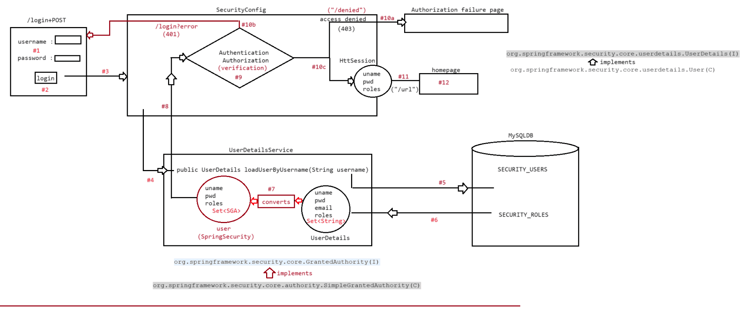
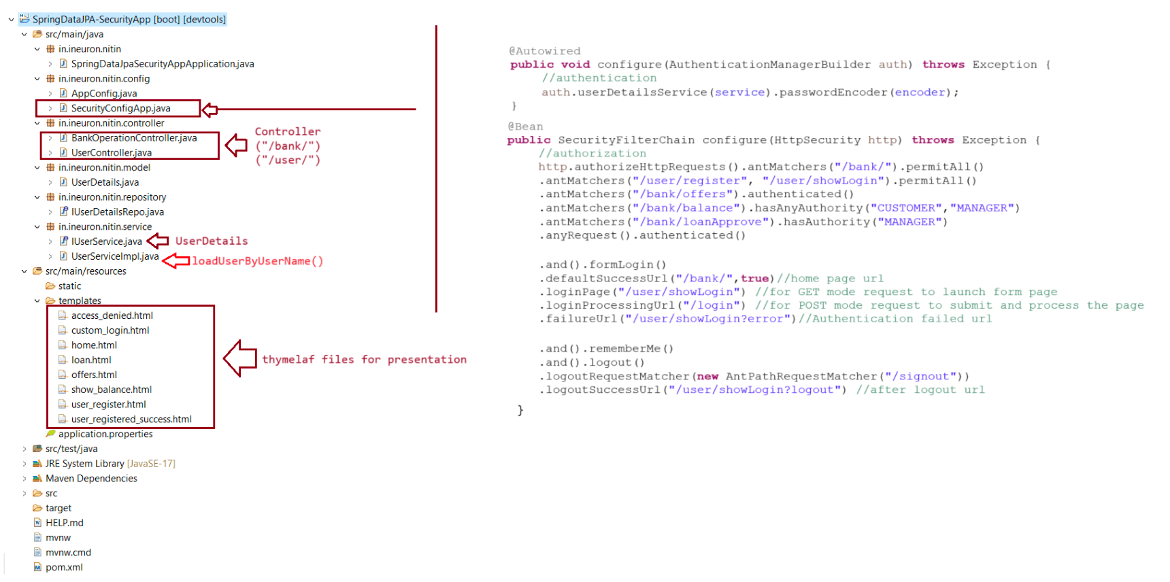
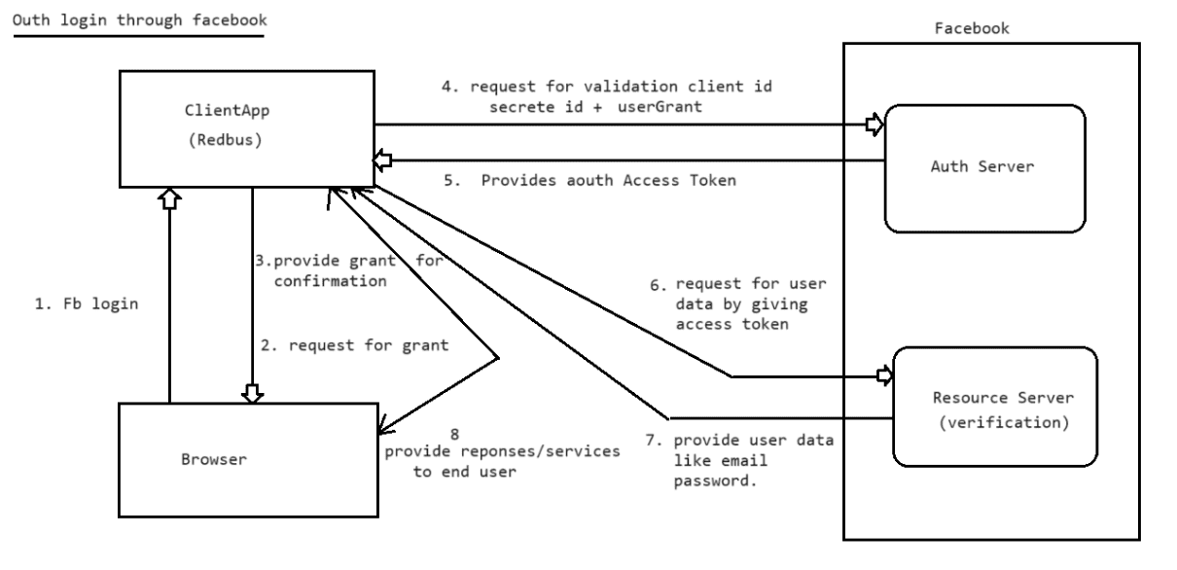
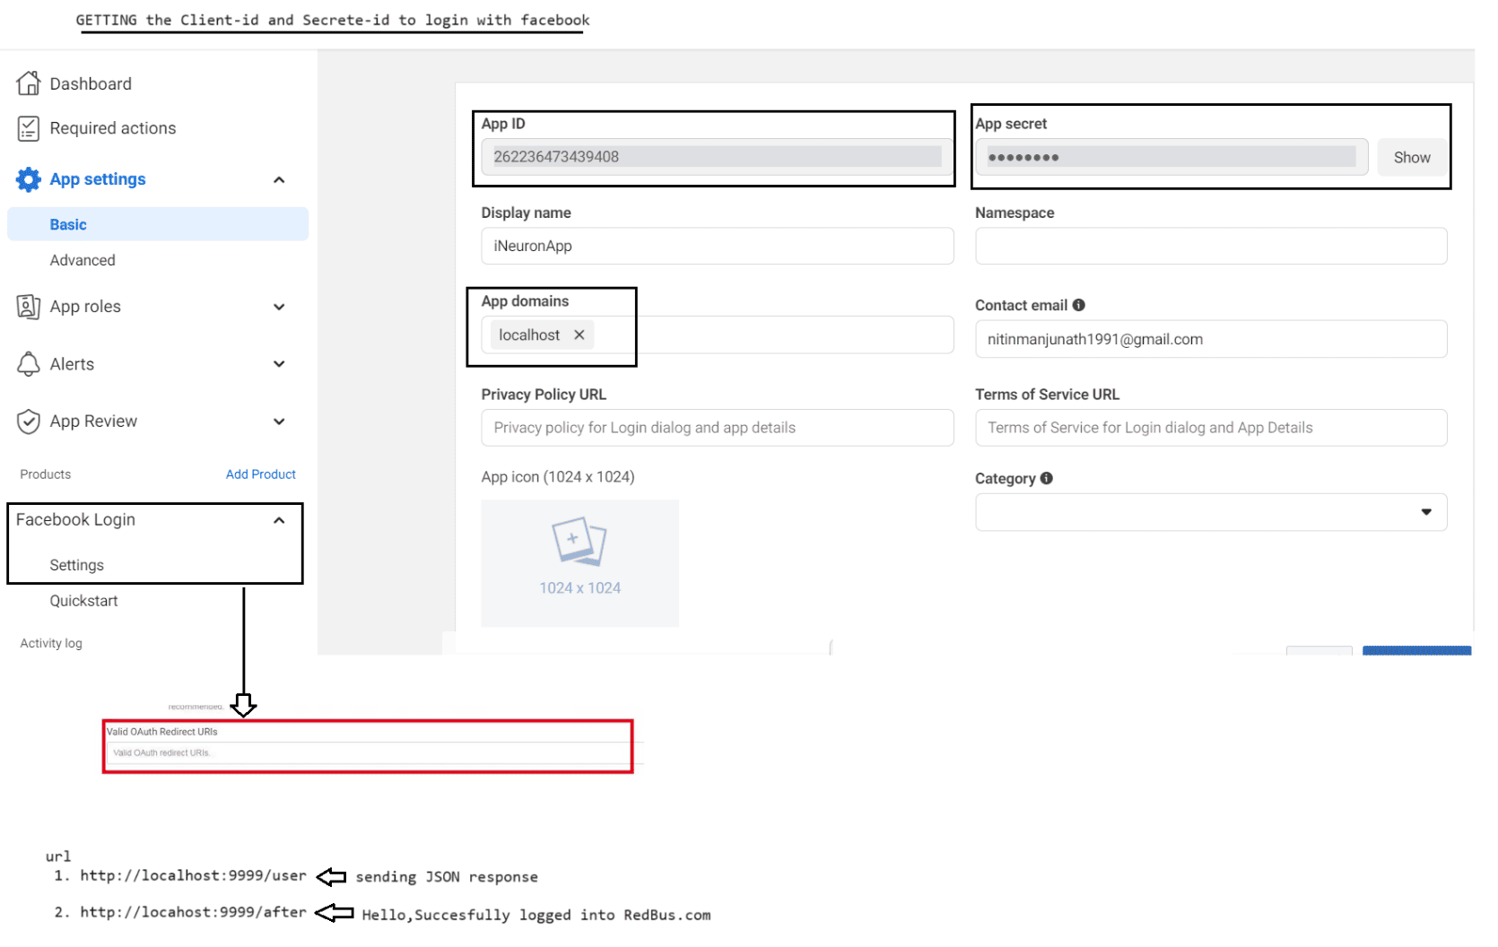

230 Working with StatelessAuthentication and StateFul Authentication , SpringSecurity using JWT, SpringSecurity using FaceBook Oauth login

+++++++++++++++++++++++
Oauth using gmail login
+++++++++++++++++++++++
Dummy credentials of gmail
Username : raghavtesting6@gmail.com
Password : Inspired@2023
1. Register Clientapp with google api
go to http://console.developers.google.com/
|
Select a project section
|
Create a new project
a. Enter a new project name(iNeuronApp)
b. Ignore location text box(default will be No Organisation)
c. click on create
2. Make iNeuronApp as the active project by selecting it
3. Go to Credentials -> click on create credentials -> click on OauthClientId->
configureConsent screen
-> select external -> click on create
provide the following details in the opened tab
a. AppName
b. UserSupport email
c. provider developer contact information
d. click on save and continue, save and continue
4.Go to credentials -> click on create credentials -> Select OuthClientId ->
application type : webapplication
now select URI : http://localhost:9999 (application uri)
now select Authorized redirect URI :
http://localhost:9999/login/oauth2/code/google (fixed uri)
now click on create
5.Copy the generated client-id and secrete-id as shown below
client-id : 971870997040-
8hpr3j36r5sn478blkk8rtln2d4eev50.apps.googleusercontent.com
secrete-id: 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
6. add these information in application.properties/.yml file
spring:
security:
oauth2:
client:
registration:
google:
client-id: 971870997040-
8hpr3j36r5sn478blkk8rtln2d4eev50.apps.googleusercontent.com
client-secret: 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
7. Create a SecurityConfigApp to control the endpoints for Authentication
++++++++++++++++++++++
SecurityConfigApp.java
++++++++++++++++++++++
package in.ineuron.nitin.configuration;
import org.springframework.context.annotation.Bean;
import org.springframework.context.annotation.Configuration;import org.springframework.security.config.annotation.web.builders.HttpSecurity;
import
org.springframework.security.config.annotation.web.configuration.EnableWebSecurity;
import org.springframework.security.web.SecurityFilterChain;
@Configuration
@EnableWebSecurity
public class SecurityConfigApp {
@Bean
Exception {
public SecurityFilterChain configureFilter(HttpSecurity http) throws
//authorization
http.authorizeHttpRequests()
.antMatchers("/","/home","/login").permitAll()
.anyRequest().authenticated()
.and().formLogin()
.and().oauth2Login();//Developing custom login form having hyperlink to
login as fb user
return http.build();
}
}
7. Add the following line in login.html page
<br>
<h1 style="color:red; text-align: center">
<a href="/oauth2/authorization/google">Google LOGIN</a>
</h1>
8. Run the application as springboot application
request
a. http://locahost:9999/home -> Hello, Welcome to Home page of RedBus.com
b. http://locahost:9999/after
|
display login page
|
click on google link
|
it redirect to gmail login page
|
chooose the user
|
Hello,Succesfully logged into RedBus.com
c. http:///localhost:9999/user
|
display the user data in Json format
+++++++++++++++++++++++
JWT(JSON Web Tokenizer)
+++++++++++++++++++++++
=> While implementing security in client-server application(either webapplication
or distrubuted application) the client authentication is very important.
=> What is clientAuthentication?
Ans.Making the enduser to submit credentials or identity to the server
application and making server app validating those details is called
"Client-Authentication".eg: Logging by submitting username and password for any applications.
Logging by using faceid
Logging by using otp
etc...
Client Authentication in Client-Server application can be done in 2 ways
a. Stateful Authentication => Working with HttpSession based
SessionManagement, Session Tracking technique
Server will hold the client state during a session.
refer: .png file
=> state reprsents the data,like client data(username,password) that is
stored at the server app and it will be used across multiple requests.
Since the server remembers the data we say such type of authentication
as "Stateful Authentication".
=> On a webapplication, if we apply session tracking then webapplicaion
remembers and stores the clientdata(state) across multiple requests.
This makes a webapplication a "StateFul" WebApplication.
b. Stateless Authentication => Working with Tokens, Generating the token we
can get the Support of JSON WEB Tokenizer(JWT)
Server doesn't hold client state in any angle.
refer : .png file
=> The server app will generate token, which goes to client and the token
will be stored at the client side.
=> This token will be sent to Server along with every request, Generally
token will have an expriy time.
=> Once the token is expired at the server side, the client sent token
will fail in token validation and the response will be sent
as "login page/error page".
=> Here no state(user,pwd) of Client are stored in server app so we say as
"StateLess Authentication".
Q> Where should Stateful Authentication and Where should we use Stateless
Authentication?
Regular webapplication which interacts with enduser directly uses "Stateful
Authentication".
eg:
Facebook.com,amazon.com,ineuron.com,redbus.com,gmail.com,flipkart.com
(SessionTracking)
In Server to Server communication nothing but restful services interaction we
need to go for "Stateless Authentication"
eg: flipkart interacting with paytm or gpay or phonepe.
+++++++++++++++++++++++++++++++++++++++++++++++++++++++++++++
Different places where Stateless Authentication will be used
+++++++++++++++++++++++++++++++++++++++++++++++++++++++++++++
1. Server to Server Communication(B2B)
2. While enabling the horizontal scaling for the aplication(Microservices)
3. While Implementing Resource Grant Security(OAuth Application)
refer: .pngBenefits of Working with Stateless Authentication
a. Since it is stateless concept, it doesn't allocate any memory at the server
side, so no burden on the server
b. It is very good for Distrubuted and also for Microservices based application
development.
Limitations
a. The token is validated on evey request.
b. If the token is passed on to other users,they can access the entire client
information and perform all operations as a Authorized client.
To implement this token based authorization, we need to generate and validate the
tokens by using the support of "JWT".
JWT is an OpenSource API, that supports generating the tokens based on the given
client details and secrete-key(password)
JWT
=> it is used for stateless authentication, which is capable of generating tokens.
=> Information is :: https://jwt.io/
=> Sample JWT token
eyJhbGciOiJIUzI1NiIsInR5cCI6IkpXVCJ9.
eyJzdWIiOiIxMjM0NTY3ODkwIiwibmFtZSI6IkpvaG4gRG9lIiwiaWF0IjoxNTE2MjM5MDIyfQ.
SflKxwRJSMeKKF2QT4fwpMeJf36POk6yJV_adQssw5c
=> The content which is not readable is called "Encoded Content".
=> JWT token message is "Encoded Content".
=> Decoding the content means => getting readable content from the encoded
content.
=> JWT toke contains 3 parts
a. HEAD : JWT Specific information like algorithm,type, etc..
b. PAYLOAD : Claims info like clienid,clientname,issuername,expirydata
c. SIGNATURE : BASE64Encoded(header) + BASE64Encoded(body/payload) mixed with
Secrete-key.
refer :.png
To generate the token and to get the claims information from generated token we use
"JWT" API.
maven depenancy
a. jjwt
b. jaxb-api
pom.xml
+++++++
<dependency>
<groupId>io.jsonwebtoken</groupId>
<artifactId>jjwt</artifactId>
<version>0.9.1</version>
</dependency>
<!-- https://mvnrepository.com/artifact/javax.xml.bind/jaxb-api -->
<dependency>
<groupId>javax.xml.bind</groupId>
<artifactId>jaxb-api</artifactId>
<version>2.3.1</version>
</dependency>
++++++++++++
JWTUtil.java++++++++++++
package in.ineuron.utility;
import java.util.Base64;
import java.util.Date;
import java.util.concurrent.TimeUnit;
import io.jsonwebtoken.Claims;
import io.jsonwebtoken.Jwts;
import io.jsonwebtoken.SignatureAlgorithm;
public class JWTUtil {
public static String generatToken(String id,String subject,String secretekey)
{
return Jwts
.builder()
.setId(id)
.setSubject(subject)
.setIssuer("PWSKILLS")
.setIssuedAt(new Date(System.currentTimeMillis()))
.setExpiration(new Date(System.currentTimeMillis() +
TimeUnit.MINUTES.toMillis(1)))
.signWith(SignatureAlgorithm.HS256,Base64.getEncoder().encode(sec
retekey.getBytes()))
.compact();
}
s()))
public static Claims getClaims(String secretkey,String token) {
return Jwts
.parser()
.setSigningKey(Base64.getEncoder().encode(secretkey.getByte
.parseClaimsJws(token)
.getBody();
}
public static boolean isTokenValid(String secretkey,String token) {
Date tokenExpiryDate = getClaims(secretkey, token).getExpiration();
Date date =new Date();
boolean result = date.before(tokenExpiryDate);
return result;
}
}
}
public static String getSubject(String secretekey,String token) {
return getClaims(secretekey, token).getSubject();
public static Date getExpiryDate(String secretekey,String token) {
return getClaims(secretekey, token).getExpiration();
}
+++++++++++++++
JWTTestApp.java
+++++++++++++++package in.ineuron.test;
import in.ineuron.utility.JWTUtil;
import io.jsonwebtoken.Claims;
public class JWTTestApp {
public static void main(String[] args) throws Exception {
String token = JWTUtil.generatToken("TRA_SCTN", "UPI-PIN", "7234");
System.out.println(token);
Claims claims = JWTUtil.getClaims("7234", token);
System.out.println("Subject info :: " + claims.getSubject());
System.out.println("Client id :: " + claims.getId());
System.out.println("Exprity date :: " + claims.getExpiration());
System.out.println("IssuedDate time :: " + claims.getIssuedAt());
System.out.println("IS Token valid :: " +
JWTUtil.isTokenValid("7234", token));
System.out.println("SubjectInfo :: " +
JWTUtil.getSubject("7234", token));
System.out.println("ExpiryDate and Time :: " +
JWTUtil.getExpiryDate("7234", token));
}
}
Output
HEAD : eyJhbGciOiJIUzI1NiJ9.
DATA/Payload :
eyJqdGkiOiJUUkFfU0NUTiIsInN1YiI6IlVQSS1QSU4iLCJpc3MiOiJQV1NLSUxMUyIsImlhdCI6MTY5NTU
0Mzc4OSwiZXhwIjoxNjk1NTQzODQ5fQ.
SIGNATURE : UKLLsnWEjhAsDJtOOCZnkh-HhkNKzgHwzK3Kh5QBFWQ
Subject info :: UPI-PIN
Client id :: TRA_SCTN
Exprity date :: Sun Sep 24 13:54:09 IST 2023
IssuedDate time :: Sun Sep 24 13:53:09 IST 2023
IS Token valid :: true
SubjectInfo :: UPI-PIN
ExpiryDate and Time :: Sun Sep 24 13:54:09 IST 2023
++++++++++++++++
RealtimeScenario
++++++++++++++++
1. Client------STATELESS Authentication----------RESTAPI
request -> GET: http://localhost:9999/hello
reponse -> {
"timestamp": "2023-09-24T08:44:23.278+00:00",
"status": 403,
"error": "Forbidden",
"message": "Access Denied",
"path": "/hello"
}
request ->POST : http://localhost:9999/authenticate
select body tab,choose raw and select JSON type
{
"username":"admin","password":"admin@123"
}
click on send
repsonse -> {
"jwt":
"eyJhbGciOiJIUzI1NiJ9.
eyJzdWIiOiJhZG1pbiIsImV4cCI6MTY5NTU4MTMxMSwiaWF0IjoxNjk1NTQ1MzExfQ.
qQoboA3ZF8lwoPubFspKOqARKU6Y8KWI2n_em5gJXrA"
}
2. Client -----STATELESS Authentication(token)----------RESTAPI
a. send the request with token
request -> GET: http://localhost:9999/hello
Choose Authorization tab
a. select Bearer token
b. paste the
token :eyJhbGciOiJIUzI1NiJ9.eyJzdWIiOiJhZG1pbiIsImV4cCI6MTY5NTU4MTMxMSwiaWF0IjoxNjk
1NTQ1MzExfQ.qQoboA3ZF8lwoPubFspKOqARKU6Y8KWI2
click on send
b. response form the endpoints
Hello World
+++++++++++++++++++
JUnit with Mockito
++++++++++++++++++
Wednesday
Thursday
+++++++++++++++++++++++++++++++++
Springboot with React integration
+++++++++++++++++++++++++++++++++
Saturday
Sunday

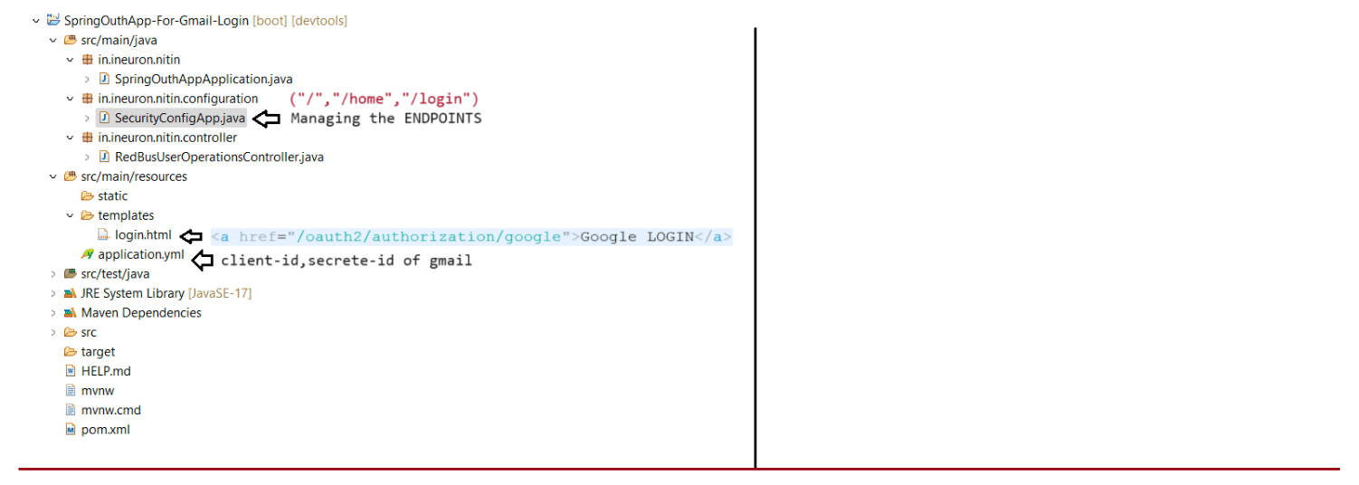
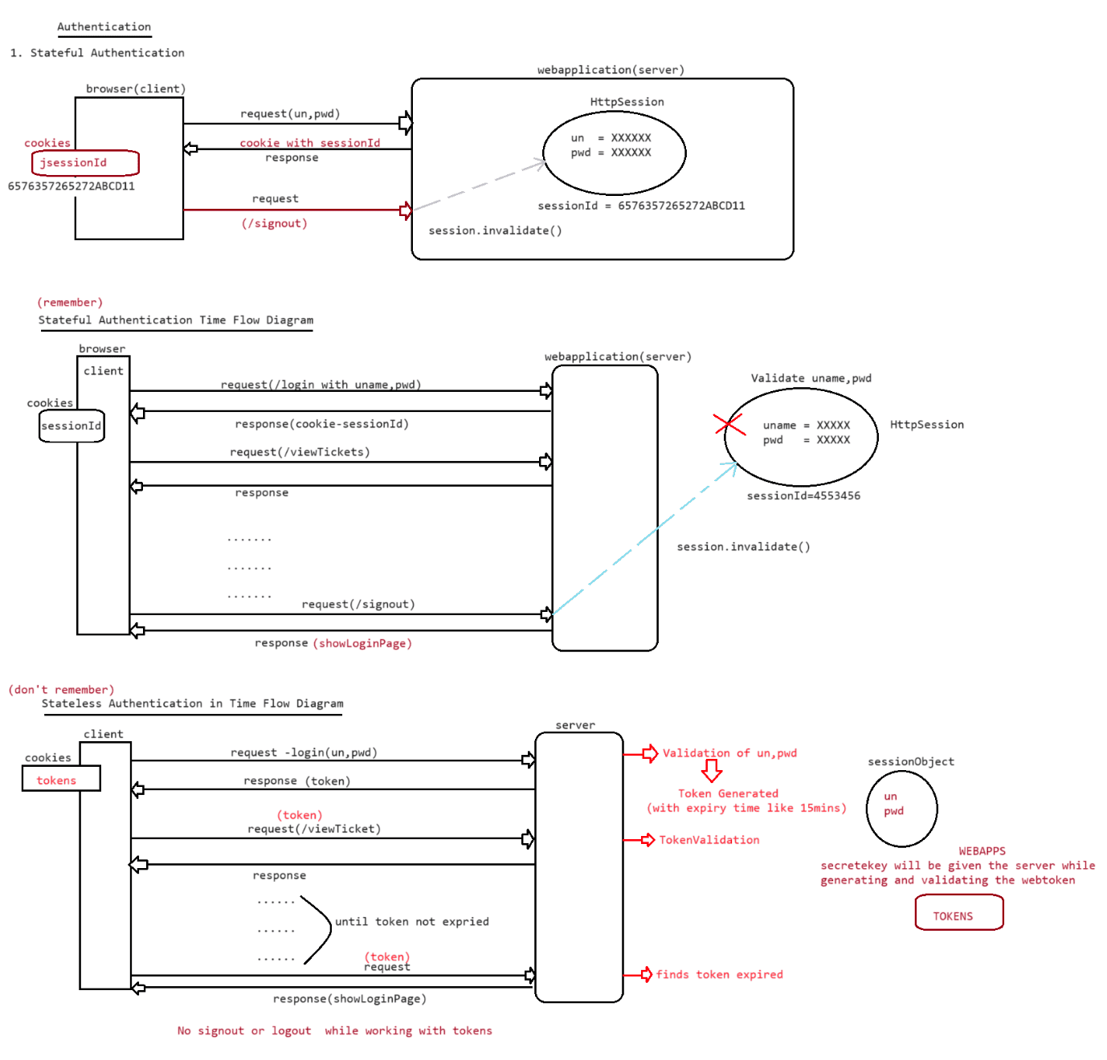
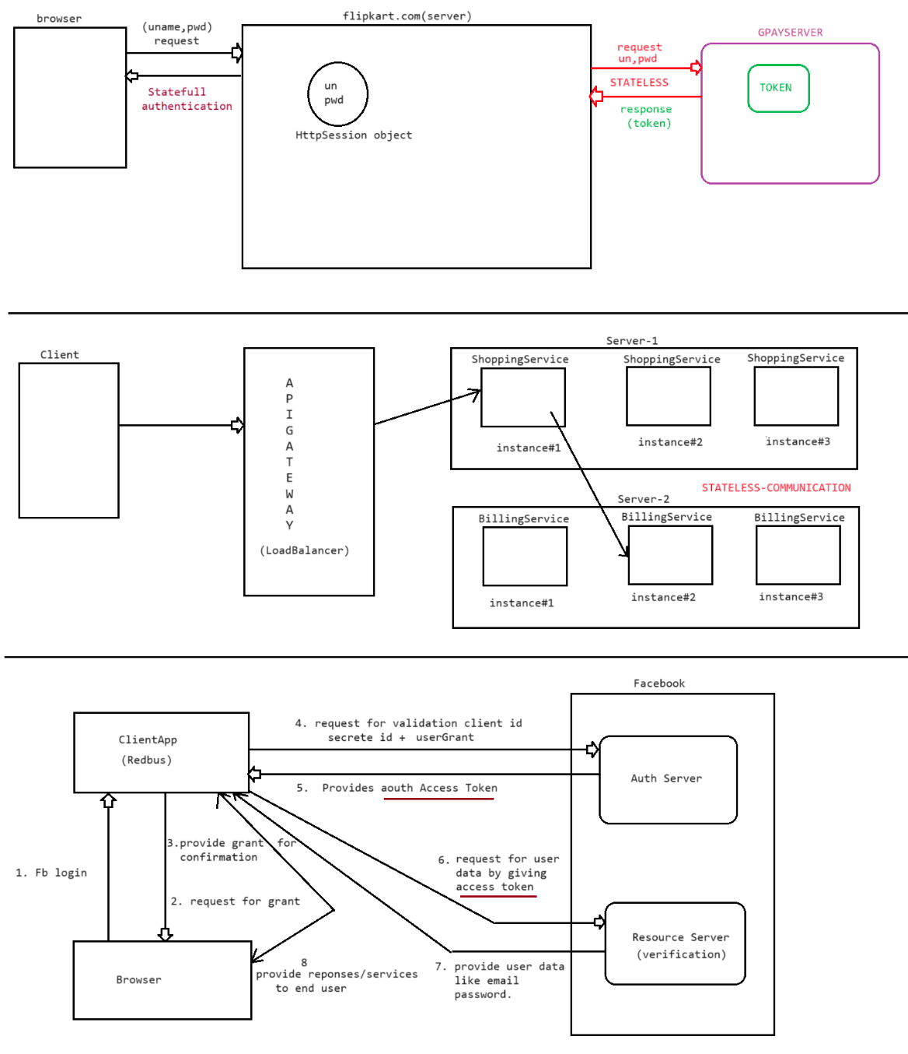
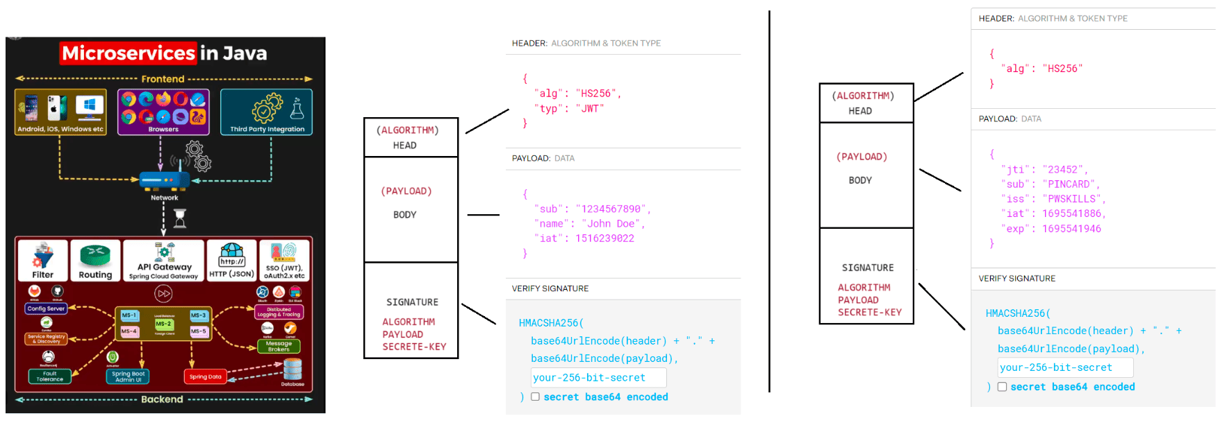

231 Junit with Maven Live Class

++++++++++++++++++++++++++++++++++++++++++++++++++++++++++++++++++++++++
Pre-requisite: Core Java + Eclipse IDE knowledge + (Advance java basics)
++++++++++++++++++++++++++++++++++++++++++++++++++++++++++++++++++++++++
JUnit
Unit Testing: The test done by programmer on own piece of code is called unit
testing.
Peer Testing: The unit testing done on 1 programmer's code/ task by his colleague
programmer is called Peer testing.
Note:
Testing = matching expected results with actual results.
if matched then test result is positive (Test succeeded).
if not matched then test result is negative (Test failed).
Development --> Unit/ Peer Testing should be done continuously by programmer until
test results are positive.
Testing done developers:
o Unit testing
o Peer testing
o Integration testing
[Under monitoring of TL] (talks about modules/ applications integration]
Testing done Testers (QA Team): (They test whole project)
o Performance Test
o Navigation Test
o User-Experience Test
o System testing
o Load Testing
o Functional Testing
o Sanity Testing and etc.
Unit testing can be done in two ways:
a. Manual Unit Testing
b. Automated Unit Testing
Limitations of Manual Unit Testing:
▪ No Productivity (takes time).
▪ Writing test report manually is complex process (Excel sheet report).
▪ Presenting Test plans/ test cases to TL or superior is complex process.
▪ Test Regression (repeating the tests) is very complex.
▪ It is not industry standard.
=> To overcome these problems, take the support Unit testing automation tools like
JUnit, HttpUnit (for web applications), Mockito,
TestNG and etc.
=> For HttpUnit, Mockito and TestNG, JUnit is the base tool (Java based Unit
Testing tools).
In Test results we can see:
a. success : expected results are matched actual results.
b. failures: expected results are not matched actual results.
c. errors : Unanticipated/ unexpected exception has come while testing the code.
Q. What is the difference between failure and error?
Ans. failure: actual code has given result but not matching expected result.
error : actual code has not given result rather it has thrown exception.While working with Junit we can see 3 main components:
1. Service class/ Main class (Class to be tested) (1 or more).
2. Test case class (The class that contains test methods) (1 or more).
3. Test Suite: Allows to combine multiple test case classes to generated the test
report (0 or 1) (optional).
Note: We can run each Test case class manually to generate Test report. But, if
want get test report of all the classes together
then take the support Test suite class.
Eclipse IDE gives built-in Support for JUnit (i.e. eclipse gives JUnit libraries as
built-in libraries)
To add Junit Libraries eclipse Java Project:
right click on project --> BUILDPATH --> configuration BUILDPATH -->
libraries tab --> classpath
|->add
Libraries JUnit --> select JUnit5.
Note: It is recommended to use Junit with Maven/Gradle Project because it gives the
support built-in Decompiled to see the source code
and other advantages.
JUnit5 contains 3 runtime libraries:
a. JUnit Jupiter: JUnit5 libraries
b. JUnit Vintage: JUnit 3/ 4 libraries (for backward compatibility)
c. JUnit Integrations: To allow JUnit integration with TestNg, Mockito and etc.
Junit5 Architecture diagram
refer: Diagram2
Junit5 Jupiter API gives:
a. Annotations(using this we develop Test cases)
b. Assertions API
|-> gives Assertions.assertXxx() methods (static methods) to match actual
results with expected result and generate test report.
++++++++++++
Annotations
++++++++++++
@Test
@DisplayName
@BeforeEach
@AfterEach
@BeforeAll
@AfterAll
@Tag
@ParameterizedTest
@ValueSource
@NullSource
@EmptySource
@NullAndEmptySource
@TestMethodOrder
@Order and etc.
++++++++++++++++++++++++++++++++++
Static Methods of Assertions class
++++++++++++++++++++++++++++++++++assertTrue
assertSame
assertNull
assertNotSame
assertNotEquals
assertNotNull
assertralse
assertEquals
assertArrayEquals
assertAll
assertThrows and etc.
Note:: Generally, The Testcase class name starts or ends with "Test" word and all
test methods generally begins with "test" word.
e.g.
BankService (main class)
public float calcSimplelntrest(-, -)
public float getBalance(-)
TestBankService or BankServiceTest (Test case class name)
public void testcalcSimplelnterest()
public void testGetBalnace()
:: we write multiple forms of these test methods to test main method/
service method in multiple angles.
Note: In Test Case classes, for each business method/ service method we need to
write variety of test methods not quantity test method.
eg#1.
Login App Code:
Possible test methods/ test plans
a. Test with Valid credentials
b. Test with Invalid credentials
c. Test with No credentials
eg#2.
Sum logic of two numbers:
Possible test methods/ test plans
▪ test with positives
▪ test with negatives
▪ test with mixed values
▪ test with zeros
▪ test with floating points
▪ test with chars/ strings
++++++++++++++++++++++++++
First Example Application
++++++++++++++++++++++++++
Step 1:
Create Maven Project in eclipse IDE as standalone Project by taking maven-
archetype-quickstart as the Project archetype and change java version to 17.
[open pom.xml and change java version to 17, Right click on the Project -
maven update the project].
File --> maven project --> next --> select maven-archetype-quickstart -> next -->
group Id: ineuronartifact Id: JUnitTestProject1
package: in.ineuron.service --> next --> finish.
Step 2: Add JUnit5 Jupiter jar in pom.xml as dependent by collecting from
mvnrepository.com in pom.xml under <dependencies> tag.
o junit-jupiter-api.5.7.0.jar
o junit-jupiter-params.5.7.0.jar [for some work with some advance topic]
o junit-jupiter-engine.5.7.0.jar
Step 3: Develop main class or service class in in.ineuron.service package of
src/main/java folder.
src/main/java: To place main source code
src/test/java: To place unit testing code (test case/ test suit classes)
Step 4: Develop Testcase class with Test Methods in src/test/java folder having
package in.ineuron.test.
Step 5: Then right click on the test class – Run As – JUnit Test
pom.xml
<dependencies>
<!-- https://mvnrepository.com/artifact/org.junit.jupiter/junit-jupiter-api
-->
<dependency>
<groupId>org.junit.jupiter</groupId>
<artifactId>junit-jupiter-api</artifactId>
<version>5.10.0</version>
<scope>test</scope>
</dependency>
<!-- https://mvnrepository.com/artifact/org.junit.jupiter/junit-jupiter-
params -->
<dependency>
<groupId>org.junit.jupiter</groupId>
<artifactId>junit-jupiter-params</artifactId>
<version>5.10.0</version>
<scope>test</scope>
</dependency>
<!-- https://mvnrepository.com/artifact/org.junit.jupiter/junit-jupiter-
engine -->
<dependency>
<groupId>org.junit.jupiter</groupId>
<artifactId>junit-jupiter-engine</artifactId>
<version>5.10.0</version>
<scope>test</scope>
</dependency>
</dependencies>
++++++++++++++++++++
BankLoanService.java
++++++++++++++++++++
package in.ineuron.service;
public class BankLoanService {
public float calculateSimpleInterest(float pamount,float rate,float time) {
System.out.println("BankLoanService.calculateSimpleInterest()");
if(pamount<=0 || rate<=0 || time <=0)throw new IllegalArgumentException("Invalid inputs");
return (pamount*rate*time)/100.0f;
}
}
@Test: To make the method of Testcase class as the Test method
assertEquals()/assertNotEquals(): To check whether expected result is equal or not
with actual result and to generate test report.
assertThrows(): To check expected exception has come or not.
Case1:
@Test
public void calculateSimpleTestInterestWithSmallNumbers() {
BankLoanService service = new BankLoanService();
float actualInterest = service.calculateSimpleInterest(100000, 2, 12);
float expected = 24000.0f;
assertEquals(expected, actualInterest);
}
@Test
public void calculateSimpleTestInterestWithBigNumbers() {
BankLoanService service = new BankLoanService();
float actualInterest = service.calculateSimpleInterest(10000000, 2, 12);
float expected = 2400000.12f;
assertEquals(expected, actualInterest)
}
Output : 2 testcase pass
Case2:
@Test
public void calculateSimpleTestInterestWithBigNumbers() {
BankLoanService service = new BankLoanService();
float actualInterest = service.calculateSimpleInterest(10000000, 2, 12);
float expected = 240000.0f;
assertEquals(expected, actualInterest);
}
Output : 1 testcase failed(expected output not matching with actual output)
Case3:
@Test
public void calculateSimpleTestInterestWithInvalidInputs() {
BankLoanService service = new BankLoanService();
float actualInterest = service.calculateSimpleInterest(0,0,0);
float expected = 2400000.00f;
assertThrows(IllegalArgumentException.class,()-
>service.calculateSimpleInterest(0, 0, 0));
}
Output : 1 testcase passed(Excpetiongenerated is IllegalArgumentException and
collected type is also IllegalArgumentException)
Case4:
@Test
public void calculateSimpleTestInterestWithInvalidInputs() {
BankLoanService service = new BankLoanService();
float actualInterest = service.calculateSimpleInterest(0,0,0);
float expected = 2400000.00f;assertThrows(ArithmeticException.class,()->service.calculateSimpleInterest(0,
0, 0));
}
Output : 1 test case failed(expected IllegalArgumentException,found
ArithmeticException)
Case5:(Customizing the exception message)
@Test
public void testcalcSimpleIntrestAmountWithInvalidInut() {
BankLoanService service = new BankLoanService();
assertThrows(ArithmeticException.class, ()-
>service.calcSimpleIntrestAmount(0, 0, 0), "may results not matching");
}
Output : 1 test case failed(may results not matching)
Case6:(change in the expected value[delta result])
@Test
public void calculateSimpleTestInterestWithBigNumbers() {
BankLoanService service = new BankLoanService();
float actualInterest = service.calculateSimpleInterest(10000000, 2, 12);
float expected = 2400000.12f;
assertEquals(expected, actualInterest,0.5,"Excepted is not matching with
equal");
}
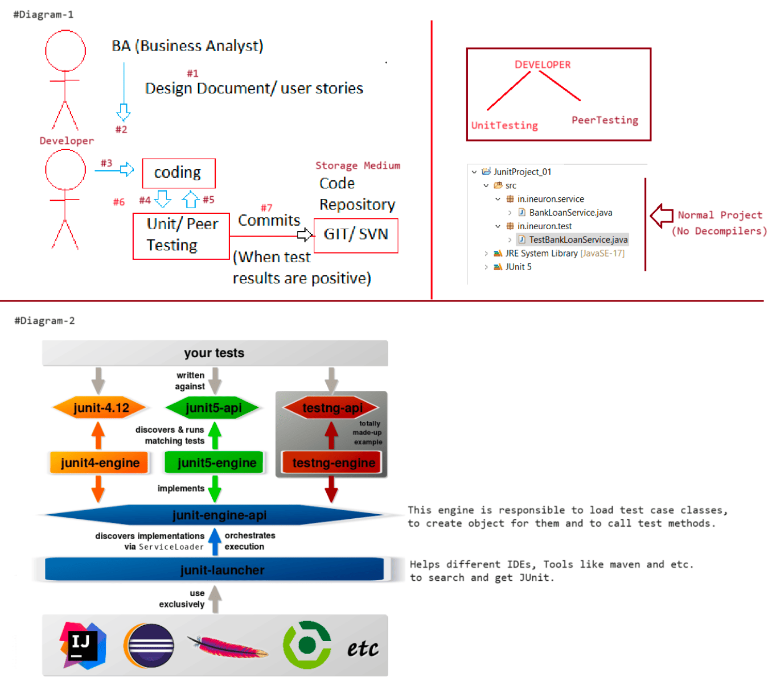
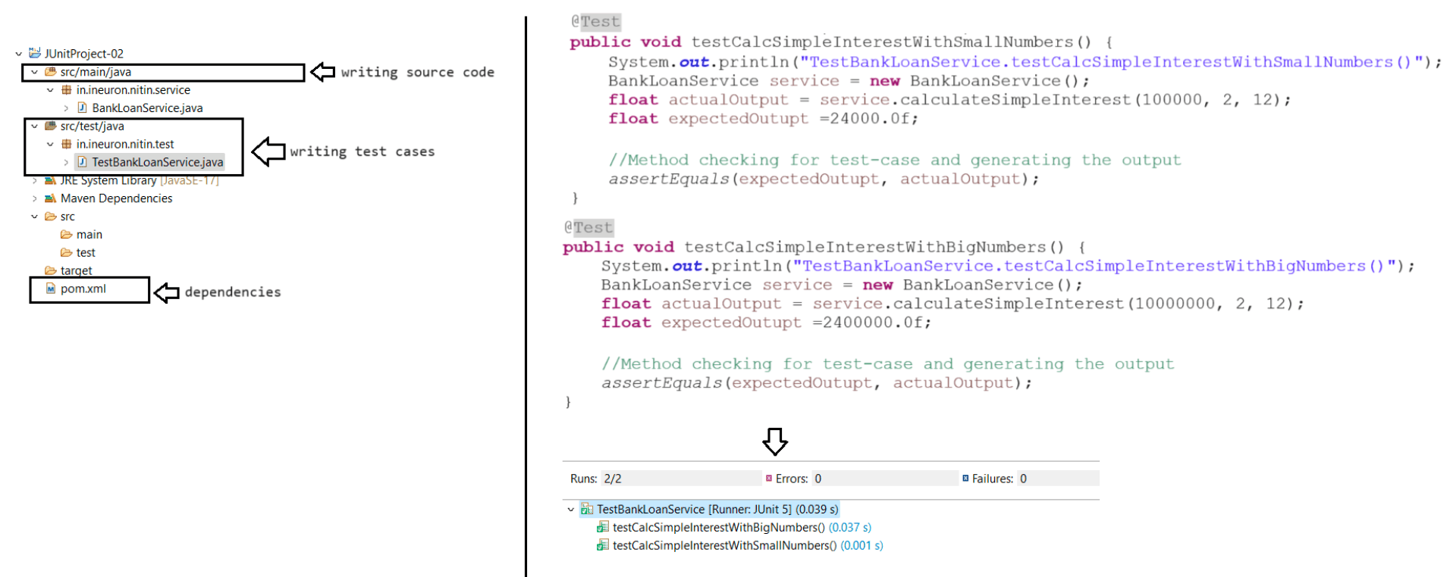

232 Junit with Maven Live Class

Case7:(Differnce b/w error and failure)
public class BankLoanService {
public float calculateSimpleInterest(float pamount,float rate,float time) {
System.out.println("BankLoanService.calculateSimpleInterest()");
if(pamount<=0 || rate<=0 || time <=0)
throw new IllegalArgumentException("Invalid inputs");
return (pamount*rate*time)/100.0f;
}
}
+++++++++++++++++++++++++++++++++++++++++++++++++++++++++++++++++++++++++++++++++++
@Test
public void calculateSimpleTestInterestWithInvalidInputs() {
BankLoanService service = new BankLoanService();
float actualInterest = service.calculateSimpleInterest(0,0,0);
float expected = 2400000.12f;
assertEquals(actualInterest, expected);//Exception generated in service class
is not handled in Test case , so it is "Error".
}
Run 1/1 Failure : 0 Error : 1
Output: java.lang.IllegalArgumentException: Invliad inputs
at
in.ineuron.nitin.service.BankLoanService.calculateSimpleInterest(BankLoanService.ja
va:7)
at
in.ineuron.nitin.test.TestBankLoanService.testCalcSimpleInterestWithInvalidInputs(T
estBankLoanService.java:38)
at java.base/jdk.internal.reflect.NativeMethodAccessorImpl.invoke0(Native
Method)
at
java.base/jdk.internal.reflect.NativeMethodAccessorImpl.invoke(NativeMethodAccessor
Impl.java:77)
at
java.base/jdk.internal.reflect.DelegatingMethodAccessorImpl.invoke(DelegatingMethod
AccessorImpl.java:43)
at java.base/java.lang.reflect.Method.invoke(Method.java:568)
at
org.junit.platform.commons.util.ReflectionUtils.invokeMethod(ReflectionUtils.java:7
25)
+++++++++++++++++++++++++++++++++++++++++++++++++++++++++++++++++++++++++++++++++++
+++++++++
Case8:(TimeDuration:300000,TimeRequired for Executed is ::200000)
public class BankLoanService {
public float calculateSimpleInterest(float pamount,float rate,float time) {
System.out.println("BankLoanService.calculateSimpleInterest()");
if(pamount<=0 || rate<=0 || time <=0)
throw new IllegalArgumentException("Invalid inputs");
try {
Thread.sleep(10000);
} catch (InterruptedException e) {
e.printStackTrace();
}
return (pamount*rate*time)/100.0f;
}
}+++++++++++++++++++++++++++++++++++++++++++++++++++++++++++++++++++
@Test
public void calculateSimpleTestInterestWithTimer() {
BankLoanService service = new BankLoanService();
assertTimeout(Duration.ofMillis(200000), () ->
service.calculateSimpleInterest(0, 0, 0));
}
Output: org.opentest4j.AssertionFailedError: execution exceeded timeout of 20000 ms
by 10007 ms
at
org.junit.jupiter.api.AssertionFailureBuilder.build(AssertionFailureBuilder.java:15
2)
at
org.junit.jupiter.api.AssertionFailureBuilder.buildAndThrow(AssertionFailureBuilder
.java:132)
at org.junit.jupiter.api.AssertTimeout.assertTimeout(AssertTimeout.java:81)
at org.junit.jupiter.api.AssertTimeout.assertTimeout(AssertTimeout.java:53)
at org.junit.jupiter.api.Assertions.assertTimeout(Assertions.java:3356)
at
in.ineuron.test.BankLoanServiceTest.calculateSimpleTestInterestWithTimer(BankLoanSe
rviceTest.java:41)
at java.base/java.lang.reflect.Method.invoke(Method.java:577)
at java.base/java.util.ArrayList.forEach(ArrayList.java:1511)
at java.base/java.util.ArrayList.forEach(ArrayList.java:1511)
=> assertTimeout(): To check whether business method execution is completed in the
specified time or not.
+++++++++++++++++++++++++++++++++++++++++++++++++++++++++++++++++++++++++++++++++++
+++++++++++++++++++++++++++++
Note:
@BeforeEach: To place common logic that should execute before each Test method
execution.
@AfterEach : To place common logic that should execute after the each Test method
execution.
case9:
class TestBankLoanService{
private BankLoanService service;
@BeforeEach
public void setUp() {
service = new BankLoanService();
}
@AfterEach
public void clear() {
service = null;
}
}
+++++++++++++++++++++++++++++++++++++++++++++++++++++++++++++++++++++++++++++++++++
++++++++++++++++++++++++++++++
Case10:
@BeforeAll: To write common logic only for 1 time for all test methods.
@AfterAll : To place cleanup logic for all test methods.
These methods must be taken as static methods
public class TestBankLoanService{
private static BankLoanService service;
@BeforeAllpublic static void setUpOnce() {
service = new BankLoanService();
}
@AfterAll
public static void clearOnce() {
service=null;
}
}
+++++++++++++++++++++++++++++++++++++++++++++++++++++++++++++++++++++++++++++++++++
++++++++++++++++++++++++++++++
Case11:
@Disabled : Marks test method as skipped/ disabled/ ignored test method
@DisplayName: To give programmer choice non-technical names to Test case class and
test methods.
@DisplayName("TestBankLoanService class")
public class TestBankLoanService {
@Test
@DisplayName("Testing with small numbers")
public void testcalcSimpleIntrestAmountWithSmallNumber() {
float actual = service.calcSimpleIntrestAmount(100000, 2, 12);
float expected = 24000.0f;
assertEquals(expected, actual, "may results not matching");
}
@Test
@Disabled
@DisplayName("Testing with timer")
public void testcalcSimpleIntrestAmountWithTimer() {
assertTimeout(Duration.ofMillis(20000), ()->{
service.calcSimpleIntrestAmount(100000, 2, 12);
});
}
}
Output: 2 testcases skipped
Testing with small numbers
Testing with timer
Case12:
@TestMethodOrder: Useful to specify execution order of test methods with different
possibilities.
@DisplayName("TestBankLoanService class")
@TestMethodOrder(value = MethodOrderer.OrderAnnotation.class)
public class TestBankLoanService {
@Order(10)
@Test
public ....(){}
@Order(0)
@Test
public ....(){}
@Order(5)
@Test
public ....(){}}
=> OrderAnnotation (best, we should add @Order(n) on top of test methods while
using this option.
=> n-> priority number high value indicates low priority and low value indicate
high priority.
Case13: Based on the MethodName(Alphabetical order)
@TestMethodOrder: Useful to specify execution order of test methods with different
possibilities.
@DisplayName("TestBankLoanService class")
@TestMethodOrder(value = MethodName.class)
public class TestBankLoanService {
}
Case14: Based on the DisplayName of the method
@TestMethodOrder(MethodOrderer.DisplayName.class)
public class BankLoanServiceTest {
}
Case15: Based on the Order of names(default followed by engine)
@DisplayName("BankLoanService")
@TestMethodOrder(MethodOrderer.Random.class)
public class BankLoanServiceTest {
}
Note:
MethodOrderer (l):
It is having multiple inner classes implementing same MethodOrderer (l) they are
a. MethodName
b. DisplayName (gives ambiguity with @DisplayName, so specify
MethodOrderer.DisplayName.class)
c. OrderAnnotation (best, we should add @Order(n) on top of test methods while
using this option.
n-> priority number high value indicates low priority and low value indicate
high priority)
d. Random (default but gives ambiguity, so specify MethodOrderer.Random.class)
e. AlphaNumeric (deprecated)
In real Scenarios we need to execute the application/ project in 4 environments:
a. Development(dev)
b. Testing(test)
c. UserAcceptance(uat)
d. Production(prod)
@Tag: Useful to mark test methods to execute only in certain environment like
"dev", "test", "uat", "prod" and etc.
So, that we can write separate test methods for "dev", "test" environment
based light weight setup like using MySQL,
Tomcat server and etc. and similarly we can write separate test methods for
"uat", "prod" environment based heavy weight
production ready setup like using Oracle, WebLogic,Wildfly and etc.
While running Test case class, we need to specify tags to include and exclude
a. In Eclipse Environment
Right click Testcase class --> Run As --> Run Configurations -->Test tab -->Configure
Include tags: uat
exclude tags: dev --> ok
Test runner: JUnit 5
Apply --> Run
++++++++++++++++++++++++
TestBankLoanService.java
++++++++++++++++++++++++
@Test
@DisplayName("Testing with Small Numbers")
@Tag("dev")
@Tag("uat")
public void testCalcSimpleInterestWithSmallNumbers() {
System.out.println("\
nTestBankLoanService.testCalcSimpleInterestWithSmallNumbers()");
float actualOutput = service.calculateSimpleInterest(100000, 2, 12);
float expectedOutupt = 24000.0f;
// Method checking for test-case and generating the output
assertEquals(expectedOutupt, actualOutput);
}
@Test
@DisplayName("Testing with Big Numbers")
@Tag("uat")
public void testCalcSimpleInterestWithBigNumbers() {
System.out.println("\
nTestBankLoanService.testCalcSimpleInterestWithBigNumbers()");
float actualOutput = service.calculateSimpleInterest(10000000, 2, 12);
float expectedOutupt = 2400000.345f;
// Method checking for test-case and generating the output
assertEquals(expectedOutupt, actualOutput, 0.5f, "Results are not Matching");
}
+++++++++++++++++++++++++++++++++++++++++++++++++++++++++++++++++++++++++++++++++
b. In Maven Environment
Specify the tag names as shown below under surefire plugin.
+++++++
pom.xml
+++++++
<plugin>
<artifactId>maven-surefire-plugin</artifactId>
<version>3.0.0-M5</version>
<configuration>
<goal>dev</goal>
<excludedGroups>uat</excludedGroups>
</configuration>
</plugin>
Right click on the Project --> Run As --> Maven test and check the output in
console.
+++++++++++++++++++++++++++++++++++++++++++++++++++++++++++++++++++++++++++++++++++
+++++++++++++++++++++++++
Note: We can pass TestInfo (I) type parameter in the test method to know more the
current test method and its executing environment like
tag name,display name, test class name, test method name and etc.
@Test
@Tag("dev")public void calculateSimpleTestInterestWithWhenNoException(TestInfo info) {
BankLoanService service = new BankLoanService();
System.out.println(info.getClass()+" "+info.getTags()+"
"+info.getDisplayName()+" "+info.getTestMethod().get().getName()
+" "+info.getTestClass().get().getClass());
assertDoesNotThrow(()->service.calculateSimpleInterest(10000, 2, 2));
}
Output
class org.junit.jupiter.engine.extension.TestInfoParameterResolver$DefaultTestInfo
[dev]
calculateSimpleTestInterestWithWhenNoException(TestInfo)
calculateSimpleTestInterestWithWhenNoException class java.lang.Class
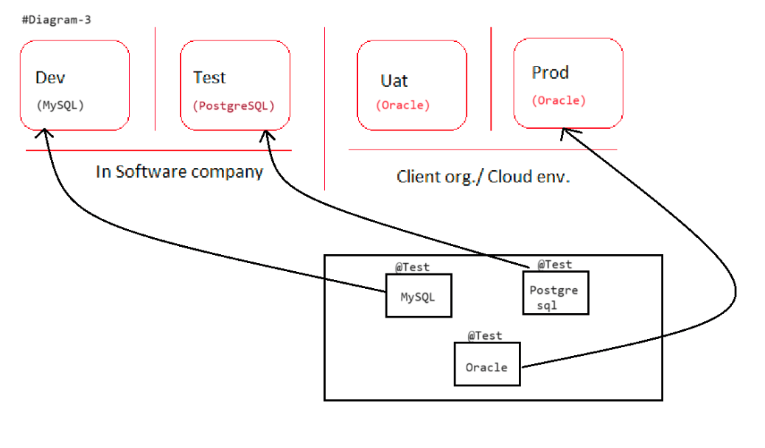

233 Junit advanced topic, HttpUnit for testing webapplications Live Class

Junit Annotations
+++++++++++++++++
1. @Test
2. @DisplayName
3. @Order
4. @Disabled
5. @Tag(Can be used to run testcases through Junit and also through Maven life
cycle)
6. @TestMethodOrder(value=..../.../...)
7. @BeforeEach
8. @BeforeAll[setUpCode() :: public static]
9. @AfterEach
10. @AfterAll[cleanUpCode():: public static]
11. @RepeatedTest(value=int,name="")
12. @ParameterizedTest(...)
13. @EmptySource
14. @NullSource
15. @NullAndEmptySource
AssertClass static methods
++++++++++++++++++++++++++
1. assertEquals(expectedOutput, actualOutput)
2. assertThrows(Exception.class,Executable(I))
3. assertTimeOut(Duration,Executable(I))
4. assertTrue(boolean)
5. asssertSame(Object expected,Object acutal)
6. assertNotNull(Object expected)
@RepeatedTest: Allows to execute test method repeatedly for multiple times having
control on count and name.
It is very useful batch processing/ updating related tests.
CensusService.java
++++++++++++++++++
package in.ineuron.service;
public class CensusService {
public String exportData() {
//logics.....
return "data exported";
}
}
TestCensusService.java
++++++++++++++++++++++
package in.ineuron.test;
import static org.junit.jupiter.api.Assertions.assertEquals;
import org.junit.jupiter.api.DisplayName;
import org.junit.jupiter.api.RepeatedTest;
import com.nt.service.CensusService;
public class TestCensusService {
@RepeatedTest(value = 10, name="execution of {displayName}-
{currentRepetition}/{totalRepetitions}")
@DisplayName("Testing data export")
public void testexportData() {
System.out.println("TestCensusService.testexportData()");
CensusService service = new CensusService();
assertEquals("data exported", service.exportData());
}}
Output
run: 10/10
TestCensusService
Testing data export
execution of Testing data export-1/10
;;;
;;;
CensusService.java
++++++++++++++++++
public boolean isOdd(int no) {
if (no%2==0)
return false;
else
return true;
public String sayHello(String user) {
return "Hello: "+user;
public boolean isEmpty(String name){
return name.isBlank();
}
}
}
TestCensusService.java
++++++++++++++++++++++
private static CensusService service;
@BeforeAll
public static void setUpOnce() {
service = new CensusService();
}
@ParameterizedTest
@ValueSource(ints = {10, 21, 34, 56, 11, 78})
public void testIsOdd(int n) {
System.out.println("TestCensusService.testIsOdd()");
assertTrue(service.isOdd(n));
}
@ValueSource(strings = {"raja", "ram"})
public void testSayHello(String user) {
System.out.println("TestCensusService.testSayHello()");
assertEquals("Hello: "+user, service.sayHello(user));
}
@ParameterizedTest
@NullAndEmptySource
public void testIsEmpty(String data) {
System.out.println("CensusServiceTest.testIsEmpty()");
Assertions.assertTrue(service.isEmpty(data));
}
@AfterAll
public static void cleanUpOnce() {
service = null;
}Q. What is the difference b/w assertEquals() and assertSame()?
Ans. assertEquals() checks content of given two values (like equals() method).
assertSame() checks whether given two references are pointing to
same object or not (like ==).
Note: If want to write failure message by writing manual checking then use fail(-)
method,once the fail() gets exectued the remaining
statements won't be executed.
++++++++++++
Printer.java
++++++++++++
public class Printer {
private static Printer INSTANCE = new Printer();
private Printer() {
}
public static Printer getInstance() {
return INSTANCE;
}
}
++++++++++++++++
PrinterTest.java
++++++++++++++++
public class PrinterTest {
@Test
public void singletonTest() {
Printer p1 = Printer.getInstance();
Printer p2 = Printer.getInstance();
Assertions.assertNotNull(p1);
Assertions.assertNotNull(p2);
if (p1 == null || p2 == null)
Assertions.fail("p1,p2 should not be null");
Assertions.assertSame(p1, p2);
}
}
++++++++
HttpUnit
++++++++
=> Unit testing for "WebApplications".
=> Generally, after developing web application, we test it by using browser to send
request and to get response (in Manual testing environment).
=> To automate the unit testing of web application, we need stimulator for the
browser software that can created using a Programming API
i.e. HttpUnit.
=> HttpUnit is developed on the top of JUnit.
Maven dependency
<!-- https://mvnrepository.com/artifact/httpunit/httpunit -->
<dependency>
<groupId>httpunit</groupId>
<artifactId>httpunit</artifactId>
<version>1.7</version>
<scope>test</scope>
</dependency>Application Development:
Step 1: Create maven project by taking maven-archetype-webapp as the archetype.
[open pom.xml and change java version to 1.8, Right click on the Project
maven update the project]
File --> maven project --> next --> select maven-archetype-webapp -->next -->
group Id: iNeuron
artifact Id: HttpUnit-LoginApp--> finish.
Step 2: Add following jars in pom.xml as dependent by collecting from
mvnrepository.com in pom.xml under <dependencies> tag.
o httpunit.1.7.3.jar
o junit-jupiter-api.5.7.0.jar
o javax.servlet.api.4.0.1.jar
o junit-jupiter-engine.5.7.0.jar
Step 3: Add index.html, verify.jsp as the web components in webapp folder having
login application logics.
Step 4: Configure Tomcat server with Eclipse IDE.
Step 5: Add Junit Test class in src/test/java folder using HttpUnit API.
Step 6: Run the LoginTest.java class as JUnit
++++++
pom.xml
+++++++
<dependencies>
<dependency>
<groupId>org.httpunit</groupId>
<artifactId>httpunit</artifactId>
<version>1.7.3</version>
<scope>test</scope>
</dependency>
<dependency>
<groupId>org.junit.jupiter</groupId>
<artifactId>junit-jupiter-api</artifactId>
<version>5.7.0</version>
<scope>test</scope>
</dependency>
<dependency>
<groupId>javax.servlet</groupId>
<artifactId>javax.servlet-api</artifactId>
<version>4.0.1</version>
<scope>provided</scope>
</dependency>
<dependency>
<groupId>org.junit.jupiter</groupId>
<artifactId>junit-jupiter-engine</artifactId>
<version>5.7.0</version>
<scope>test</scope>
</dependency>
</dependencies>
2. Create a index.html in src/main/webapp folder[public area]index.html
++++++++++
<!DOCTYPE html PUBLIC "-//W3C//DTD HTML 4.01 Frameset//EN"
"http://www.w3.org/TR/html4/frameset.dtd">
<html>
<head>
<meta http-equiv="Content-Type" content="text/html; charset=ISO-8859-1">
<title>Login Page</title>
</head>
<body>
<form action="verify.jsp" method="POST">
<table border="0" bgcolor="cyan" align="center">
<tr>
<td>Enter username:</td>
<td><input type="text" name="uname"></td>
</tr>
<tr>
<td>Enter password:</td>
<td><input type="password" name="password"></td>
</tr>
<tr>
</tr>
</table>
<td colspan="2"><input type="submit" value="Login"></td>
</form>
</body>
</html>
3. Create verify.jsp in src/main/webapp folder[public area]
verify.jsp
++++++++++
<%@ page language="java" contentType="text/html; charset=ISO-8859-1"
pageEncoding="ISO-8859-1"%>
<%
//read form data
String user = request.getParameter("uname").trim();
String pwd = request.getParameter("password").trim();
if(user.length()==0||user.equals("")||pwd.length()==0||pwd.equals("")) {
out.print("provide credentials");
return;
}
//write login/ authentication logic
if(user.equalsIgnoreCase("sachin")&&pwd.equalsIgnoreCase("tendulkar"))
out.print("valid credential");
else
out.print("invalid credential");
%>
4. Prepare a LoginTest.java in src/test/java folder
++++++++++++++
LoginTest.java
++++++++++++++
public class LoginTest {private static WebConversation conversation;
@BeforeAll
public static void setUpOnce() {
conversation = new WebConversation();
}
@Test
public void testWithValidCredentials() throws Exception {
String url = "http://localhost:9999/HttpUnit-LoginApp/index.html";
//get response by geneating request to index.html
WebResponse response = conversation.getResponse(url);
//get access to the form from the response
WebForm form = response.getForms()[0];
//set request param values to the form object
form.setParameter("uname", "sachin");
form.setParameter("password", "tendulkar");
//submit the form and get the reponse
WebResponse actualResponse = form.submit();
// get actual output from actualResponse obj
String actualOutput = actualResponse.getText().trim();
// perform assertion (compare atual results with expected results)
assertEquals("valid credential", actualOutput);
}
@Test
public void testWithInvalidCredentials() throws Exception {
String url = "http://localhost:9999/HttpUnit-LoginApp/index.html";
WebResponse response = conversation.getResponse(url);
WebForm form = response.getForms()[0];
form.setParameter("uname", "root");
form.setParameter("password", "root123");
WebResponse actualResponse = form.submit();
String actualOutput = actualResponse.getText().trim();
assertEquals("invalid credential", actualOutput);
}
@Test
public void testWithNoCredentials() throws Exception {
String url = "http://localhost:9999/HttpUnit-LoginApp/index.html";
WebResponse response = conversation.getResponse(url);
WebForm form = response.getForms()[0];
form.setParameter("uname", "");
form.setParameter("password", "");
WebResponse actualResponse = form.submit();
String actualOutput = actualResponse.getText().trim();
assertEquals("provide credentials", actualOutput);
}
@AfterAllpublic static void cleanOnce() {
conversation = null;
}
}
5. Run the server and Check it manually(url : http://localhost:9999/HttpUnit-
LoginApp/index.html)
6. Run the test cases now and observe the Junit tab for the result of the test
cases.

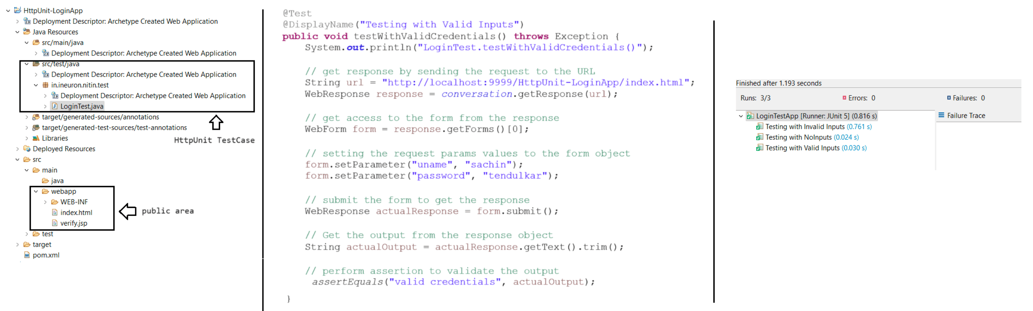

234 Junit advanced topic, HttpUnit for testing webapplications Live Class
Junit Annotations
+++++++++++++++++
1. @Test
2. @DisplayName
3. @Order
4. @Disabled
5. @Tag(Can be used to run testcases through Junit and also through Maven life
cycle)
6. @TestMethodOrder(value=..../.../...)
7. @BeforeEach
8. @BeforeAll[setUpCode() :: public static]
9. @AfterEach
10. @AfterAll[cleanUpCode():: public static]
11. @RepeatedTest(value=int,name="")
12. @ParameterizedTest(...)
13. @EmptySource
14. @NullSource
15. @NullAndEmptySource
AssertClass static methods
++++++++++++++++++++++++++
1. assertEquals(expectedOutput, actualOutput) :: deals with content(value)
2. assertThrows(Exception.class,Executable(I))
3. assertTimeOut(Duration,Executable(I))
4. assertTrue(boolean)
5. asssertSame(Object expected,Object acutal) :: deals with reference(==)
6. assertNotNull(Object expected)
HttpUnit
++++++++
WebConversation :: It is used to automate the request-response phase of Client-
Server architecture in webapplications.
+++++++
Mockito
+++++++
=> It is built on top of Junit
=> It is given to perform unit testing by mocking the Local Dependent or external
Dependent objects.
Service class ---------------------------> DAO class ---------------------->
DB s/w
|->business methods |-> Persistence methods
(having business logic) (persistence logic)
=> Let us assume DAO class coding is not completed, but Service coding is completed
and we want finish unit testing of service class.
Then we need to create Mock object/Fake object/Dummy object for DAO class and
assign/inject to Service class, in order write
test cases on service class methods.
eg#2 (paid)
Sherkhan.com<----------Inject--------------------BSE Component
(ServiceClass) (Distrubuted component)
=> When Sharekhan.com website is under development, we cannot take subscription of
BSE component because they charge money for that.
Generally, this subscription will take after hosting/ releasing the
Sharekhan.com till that we need to take one mock BSE component
and assign to Service class of Sharekhan.com to perform Unit Testing.Note: Mock objects are for temporary needs, mostly they will be used in the Unit
Testing. These mock objects created in test methods
or Test case class does not affect real code.
We can do this Mocking in 3 ways:
a. Using Mock object/ Fake object (Provides Temporary object)
b. Using Stub object (Providing some Functionality for the methods of mock object
like specifying for certain inputs,certain output should come)
c. Using Spy object (It is called Partial Mock object/ Half mock object that means
if you provide new functionality to method that will be
used otherwise real object functionality will be used).
Note: While working with Spy object we will be having real object also.
=> Instead of creating classes manually to prepare Mock, Stub and Spy objects, we
can use mocking frameworks available in the market which
are capable generate such classes dynamically at runtime as InMemory classes
(That classes that are generated in the JVM memory of RAM).
Note::
1. Normal Class
Compilation
.java(HDD)--javac--> .class(HDD)
Execution
.class(HDD) ---JVM--> Output
2. InMemory Class
RunTime RunTime
.java(JVM Memory)-------->bytecode(JVM Memory)---------> JVM ----> Output
List of Mocking Frameworks:
o Mockito (popular)
o JMockito
o EasyMock
o PowerMock
And etc.
Example Application setup:[Testing LoginMgmtService class without keeping LoginDAO
class ready]
Step 1: Create maven standalone App
File -> Maven Project -> next -> select maven-archetype-quickstart ->
Groupld: ineuron
Artifactld: MockitoUniTesting-LoginApp
Default package: in.ineuron.service
Step 2: Do following operations in pom.xml file,change java version to 1.8
Add the following dependencies (jars)
o junit-jupiter-api.5.7.0.jar
o junit-jupiter-engine.5.7.0.jar
o mockito-core.3.6.28.jar
Step 3: Develop service interface, service class
src/main/java
in.ineuron.service
|-> ILoginMgmtService.java (I)
|-> LoginMgmtServiceImpl.java (c)in.ineuron.dao
|-> LoginDAO.java
src/test/java
in.ineuron.test
|-> TestLoginMgmtService.java(C)
Step 4: Develop Mockito based Test classes and DAO interface
Step 5: Run Tests.
ILoginDao.java
+++++++++++++++
public interface ILoginDao {
public int authenticate(String username, String password);
}
ILoginMgmtService.java
++++++++++++++++++++++
public interface ILoginMgmtService {
public boolean login(String username, String password);
}
LoginMgmtServiceImpl.java
+++++++++++++++++++++++++
public class LoginMgmtServiceImpl implements ILoginMgmtService {
private ILoginDao dao;
public LoginMgmtServiceImpl(ILoginDao dao) {
this.dao = dao;
}
@Override
public boolean login(String username, String password) {
if (username.equals("") || password.equals("")) {
throw new IllegalArgumentException("Empty Credentials...");
}
// use DAO
int count = dao.authenticate(username, password);
if (count == 0) {
return false;
} else {
return true;
}
}
}
Performing UnitTesting on Service class method called "login(username,password)"
TestLoginMgmtService.java
+++++++++++++++++++++++++
public class TestLoginMgmtService {
private static ILoginMgmtService service;
private static ILoginDao loginDaoMock;@BeforeAll
public static void setUpOnce() {
loginDaoMock = Mockito.mock(ILoginDao.class);
System.out.println(loginDaoMock.getClass().getName()
+""+Arrays.toString(loginDaoMock.getClass().getInterfaces()) );
service = new LoginMgmtServiceImpl(loginDaoMock);
}
@AfterAll
public static void cleanUpOnce() {
loginDaoMock = null;
service = null;
}
@Test
public void testLoginWithValidCredentials() {
Mockito.when(loginDaoMock.authenticate("root",
"root123")).thenReturn(1);
Assertions.assertTrue(service.login("root", "root123"));
}
@Test
public void testLoginWithInValidCredentials() {
Mockito.when(loginDaoMock.authenticate("root",
"root123@")).thenReturn(0);
Assertions.assertFalse(service.login("root", "root123@"));
}
@Test
public void testLoginWithNoCredentials() {
Mockito.when(loginDaoMock.authenticate("", "")).thenReturn(0);
Assertions.assertThrows(IllegalArgumentException.class, () ->
service.login("",""));
}
}
Difference b/w Mock and Spy object
++++++++++++++++++++++++++++++++++
public class MockSpyTest {
@Test
public void testList() {
List<String> listMock = Mockito.mock(ArrayList.class);//mock object
List<String> listSpy = Mockito.spy(new
ArrayList<String>());//spyobject
listMock.add("table");
listSpy.add("sachin");
System.out.println(listMock.size()+" "+listSpy.size());
}
}
Output
0 1
Stubbing on Spy and Mock Object
+++++++++++++++++++++++++++++++
public class MockSpyTest {@Test
public void testList() {
List<String> listMock = Mockito.mock(ArrayList.class);//mock object
List<String> listSpy = Mockito.spy(new ArrayList<String>());//spy
object
listMock.add("table");
Mockito.when(listMock.size()).thenReturn(10);//stubbing the mocking
object
listSpy.add("sachin");
Mockito.when(listSpy.size()).thenReturn(10);//stubbing on spy object
System.out.println(listMock.size()+" "+listSpy.size());
}
}
Output
10 10
Note: Spy objects are useful to check how many time methods are called whether they
are called or not. Because Spy object is always linked with
real object (for this use Mockito.verify(-,-) method).
ILoginDao.java
++++++++++++++
public interface ILoginDao {
public int addUser(String user, String role);
}
ILoginMgmtService.java
++++++++++++++++++++++
public interface ILoginMgmtService {
public String registerUser(String username,String roles);
}
LoginMgmtServiceImpl.java
+++++++++++++++++++++++++
public String registerUser(String username, String roles) {
if (!roles.equalsIgnoreCase("") && !roles.equalsIgnoreCase("visitor")) {
dao.addUser(username, roles);
return "User added";
} else
return "User not added";
}
}
TestLoginMgmtService.java
+++++++++++++++++++++++++
@Test
public void testRegisterUser() {
ILoginDao loginDaoSpy=Mockito.spy(ILoginDao.class);
ILoginMgmtService service = new LoginMgmtServiceImpl(loginDaoSpy);
service.registerUser("sachin", "admin");
service.registerUser("dhoni", "visitor");service.registerUser("kohli","");
Mockito.verify(loginDaoSpy,Mockito.times(1)).addUser("sachin", "admin");
Mockito.verify(loginDaoSpy,Mockito.times(0)).addUser("dhoni", "visitor");
Mockito.verify(loginDaoSpy,Mockito.never()).addUser("kohli", "");
}
Mockito Annotations:
▪ @Mock: To generate mock object
▪ @Spy: To generate spy object
▪ @lnjectMocks: To Inject Mock or Spy Objects Service class.
MockitoAnnotations.openMocks(this); - call this method in @Before or constructor
Testcase class in order to activate Mockito Annotations.
+++++++++++++++++++++++++++++++++++
AnnotationTestLoginServiceImpl.java
+++++++++++++++++++++++++++++++++++
public class AnnotationTestLoginServiceImpl {
@Mock
private static ILoginDao loginDaoMock;
@Spy
private static ILoginDao loginDaoSpy;
@InjectMocks
private static LoginServiceImpl loginService;
public AnnotationTestLoginServiceImpl() {
MockitoAnnotations.openMocks(this);
}
@Test
public void testLoginWithNoCredentials() {
System.out.println(loginService);
assertThrows(IllegalArgumentException.class, () ->
loginService.login("", ""));
}
@Test
public void testRegisterWithSpy() {
ILoginDao loginDaoSpy = Mockito.spy(ILoginDao.class);
System.out.println("Spy object is :: " +
loginDaoSpy.getClass().getName());
LoginServiceImpl loginService = new LoginServiceImpl(loginDaoSpy);
System.out.println("AnnotationTestLoginServiceImpl.testRegisterWithSpy() ::
"+loginService);
loginService.registerUser("sachin", "admin");
loginService.registerUser("dhoni", "visitor");
loginService.registerUser("kohli", "");
Mockito.verify(loginDaoSpy, Mockito.times(1)).addUser("sachin","admin");
Mockito.verify(loginDaoSpy, Mockito.times(0)).addUser("dhoni",
"visitor");
Mockito.verify(loginDaoSpy, Mockito.never()).addUser("kohli", "");
}
@Test
public void testLoginWithInValidCredentials() {
System.out.println(loginService);
// Provide stub(providing functionality) for DAO authenticate method
Mockito.when(loginDaoMock.authenticate("sachin",
"sachin@123")).thenReturn(0);
// call login method to get the result
boolean acutalOutput = loginService.login("sachin", "sachin@123");
// compare the boolean result using assert
assertFalse(acutalOutput);
}
}
Note: To write stub functionality according agile user stories/ JIRA user stories
(given, when, then)
BDDMockito.given(loginDAOMock.authenticate("sachin",
"tendulkar")).willReturn(1);
|
Mockito.when(loginDAOMock.authenticate("sachin", "tendulkar")).thenReturn(1);
What is CSRF problem?
CSRF :: It stands for CrossSiteRequestForgery Problem.
It stands for fishing or hacking technique of hacker or attacker, who makes the
innocent enduser sendhing his data to usersites and accounts.
eg: sending spammails,trapping mails
for different websites the attacker makes the victim to send following
details by showing lottery ticket details.
<form action ="http://icicibank.com/transferfunds" method="POST">
<input type="hidden" name="amount" value="10000"/>
<input type="hidden" name="srcAccount" value="444555666"/>
<input type="hidden" name="desAccount" value="656778"/>
<input type='submit' value='clickheretowinlottery'/>
</form>
(or)
<a href='http://icicibank.com/transferfunds?
amount=10000&srcAccount=444555666&desAccount=656778">Click here to win Lottery </a>
+++++++++++++++++++++++++++++++
Feeling CSRF problem practially
+++++++++++++++++++++++++++++++
1. By default CSRF will be enabled in SpringBoot or Spring applications.
http.csrf().disable();
2. run springboot security application with authentication and to use one or two
services
http://localhost:99999/bank/|
click on check balance
|
username : sachin
password : tendulkar
click on login ==========> ShowBalance Page
balance :: 40734312
Home
logout
3. Create another dynamic webproject with an index.html page
index.html
++++++++++
<!DOCTYPE html PUBLIC "-//W3C//DTD HTML 4.01 Transitional//EN"
"http://www.w3.org/TR/html4/loose.dtd">
<html>
<head>
<meta http-equiv="Content-Type" content="text/html; charset=ISO-8859-1">
<title>Login Page</title>
</head>
<body>
<form action="http://localhost:9999/bank/balance" method="post"">
<input type="submit" value="click here to win lottery" />
</form>
</body>
</html>
4. Run the application by keeping the oldbrowser ready, without logout
we can feel the fishing or hacking problem by clicking the button.
++++++++++++++++
Solution to CSRF
++++++++++++++++
1. make sure CSRF is disabled in "SecurityConfig" class.[default it will be enabled
in SpringBoot]
2. add CSRF token in custom-login.html which is a form page
<input type="hidden" th:name="${_csrf.parameterName}" th:value="$
{_csrf.token}"/>
3. In another webapplication index.html try to send the request
<form action="http://localhost:9999/bank/balance" method="post"">
<input type="submit" value="click here to win lottery" />
</form>
How does CSRF internally works?
when csrf protection is enabled,one session token will be generated as a session
attribute having
_csrf as token name and "32" digits hexadecimal value.
using the following hidden box
<input type="hidden" th:name="${_csrf.parameterName}" th:value="$
{_csrf.token}"/>
we try to get the csrf token name and token value to the form page along with
submission.
The security environment at the server side takes the token name and value coming
from browser and validates with already available session
token value. if it is matching then the activities will be continued or allowed, ifrequest comes with invalid token or no token then
error will be used.
Client-Server Architecture in realtime
++++++++++++++++++++++++++++++++++++++
React application
Angular application (reactlibrary) @CrossOrigin("*")
Mobile application -----axios(http)------------> Restful Controller ------------
ServiceLayer--------DAOLayer----> Database
Postman application
chrome browser
==>Wednesday{React with SpringBoot Integration}
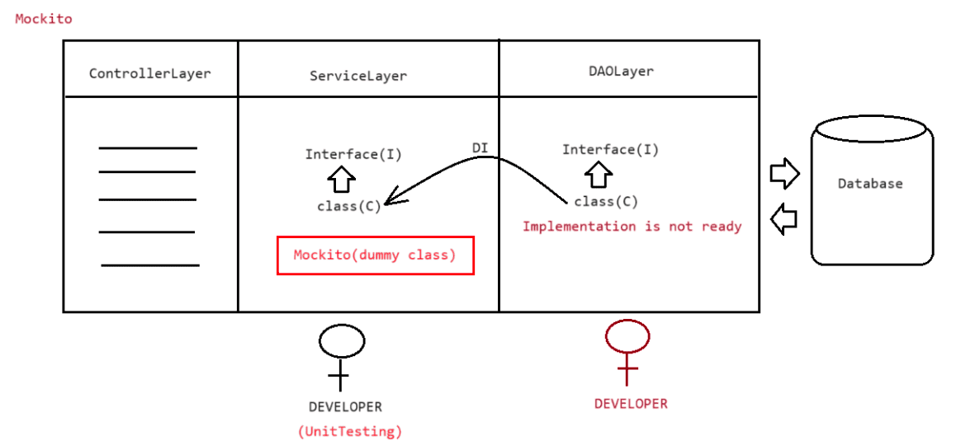
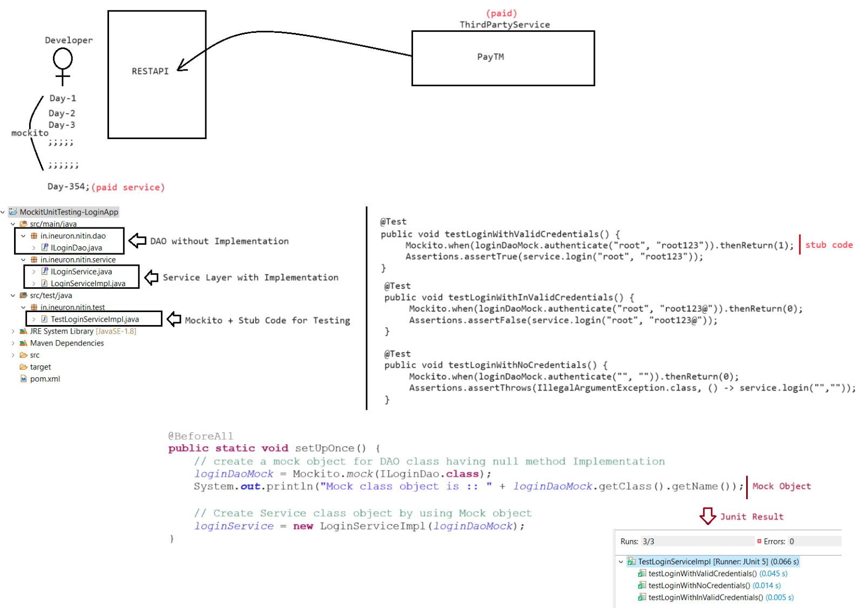
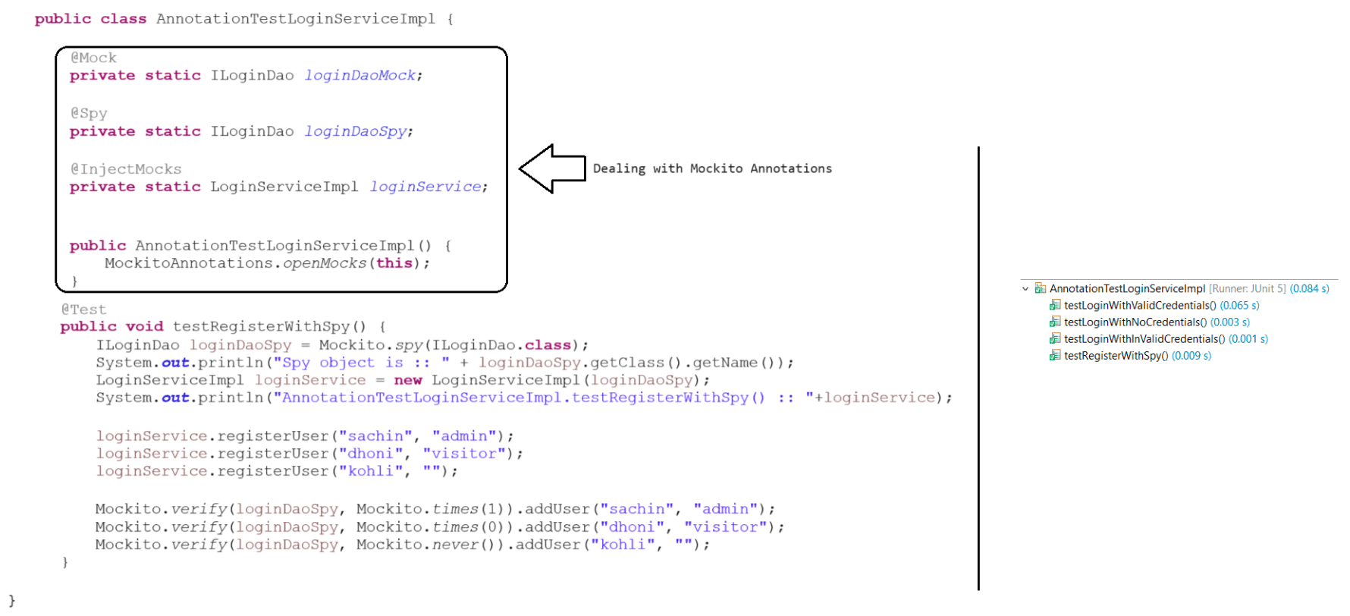

235 SpringBoot and React integration live class

React with SpringBoot Integration
+++++++++++++++++++++++++++++++++
To-Do-List
++++++++++
1. Understand the Architecture of Integrating SpringBoot(Producer) with
React(Consumer)
a. ReactApp will send the request using Axios(HTTP Library) to SpringBootApp
b. Response will be sent in the form of JSON to ReactApp
c. SpringBootApp(Producer::Java) and ReactApp(Consumer::JavaScript) --->
[Distrubuted Application environment(JSON)]
2. Flow diagram of SpringBoot
a. Controller(SpringRest)
b. Service(SpringAOP)
c. DAO (DataJPA)
Flow diagram of React
a. Router(guides for what request what component should be rendered)
b. Component(Tells what each thing represent of page)
c. Service[AxiosHttpLibrary](Makes a API call to backend and gets the data)
3. Pre-Requistes for Backend and front-end
refer diagram
4. Creating a SpringBoot project to make backend Ready
ENDPOINT
1. //GET ALL EMPLOYEES :: http://localhost:9999/api/v1/employees
5. Creating a UI using React
D:\UI-Frontend> npx create-react-app react-frontend
We suggest that you begin by typing:
cd react-frontend
npm start
D:\UI-Frontend> cd react-frontend
D:\UI-Frontend\react-frontend> npm start
You can now view react-frontend in the browser.
Local: http://localhost:3000
On Your Network: http://192.168.0.102:3000
Scene1:Go to App.js and do the following changes to understand the control flow
++++++
App.js
++++++
import './App.css';
function App() {
return (
<div className="App">
<h1>Welcome to the world of React</h1>
</div>
);
}
export default App;
Output: Welcome to the world of React
Control flow
1> index.html-------id=root------> index.js --------root.render(<App/>)------Component------> App.js
Scene2: Adding bootstrap4 to React App
Open new terminal and navigate to react-frontend
D:\UI-Frontend> cd react-frontend
D:\UI-Frontend\react-frontend> npm i bootstrap@4
Note: refer package.json file to see whether bootstrap is added or not to our
project.
dependencies": {
"@testing-library/jest-dom": "^5.17.0",
"@testing-library/react": "^13.4.0",
"@testing-library/user-event": "^13.5.0",
"bootstrap": "^4.6.2", //added to our project
"react": "^18.2.0",
"react-dom": "^18.2.0",
"react-scripts": "5.0.1",
"web-vitals": "^2.1.4"
}
Scene3:
1. Create a folder called component in src
2. Create a file called ListEmployeeComponent.jsx
ListEmployeeComponent.jsx
+++++++++++++++++++++++++
import React, { useState } from 'react';
function ListEmployeeComponent() {
const [employees, setEmployees] = useState([]);
return (
<div className="m-4">
<h2 className="text-center">Employees List</h2>
<div className="row">
<table className="table table-striped table-bordered">
<thead>
<tr>
<th> Employee First Name</th>
<th> Employee Last Name</th>
<th> Employee Email Id</th>
<th> Actions</th>
</tr>
</thead>
<tbody>
{employees.map((employee) => (
<tr key={employee.id}>
<td> {employee.firstName}</td>
<td> {employee.lastName}</td>
<td> {employee.emailId}</td>
</tr>
))}
</tbody>
</table>
</div>
</div>
);}
export default ListEmployeeComponent;
+++++++++++++++++++++++++++++++++++++++++++++++++++++++++++++++++++++++++++++++++++
++++++++++++++++++++++++++
In App.js make the following changes
App.js
+++++
import './App.css';
import 'bootstrap/dist/css/bootstrap.min.css'
import ListEmployeeComponent from './component/ListEmployeeComponent';
function App() {
return (
<div className="App">
<ListEmployeeComponent/>
</div>
);
}
export default App;
output: Check the browser, it should display the empty page with the Employee Table
with no data(only columns)
+++++++++++++++++++++++++++++++++++++++++++++++++++++++++++++++++++++++++++++++++++
++++++++++++++++++++++++++++
3. install axios library to our react project
D:\UI-Frontend\react-frontend> npm install axios --save
4.Create a folder called services in src folder
Create a file called EmployeeService.js
++++++++++++++++++
EmployeeService.js
++++++++++++++++++
import axios from 'axios';
const EMPLOYEE_API_BASE_URL = "http://localhost:9999/api/v1/employees";
export const getEmployees = () => {
return axios.get(EMPLOYEE_API_BASE_URL);
};
5. Make suitable changes in ListEmployeeComponent.jsx to call and API and render
the data on the page
+++++++++++++++++++++++++
ListEmployeeComponent.jsx
+++++++++++++++++++++++++
import React, { useState,useEffect } from 'react';
import {getEmployees} from "../services/EmployeeService"
function ListEmployeeComponent() {
//employees <----setEmployees()const [employees, setEmployees] = useState([]);
//React hook to get the JSON data
useEffect(() => {
//Calling API From BackEnd to get the data of Employees
getEmployees().then((emp) => {
//Inject data to employees varaible
setEmployees(emp.data);
});
}, []);
return (
<div className="m-4">
<h2 className="text-center">Employees List</h2>
<div className="row">
<table className="table table-striped table-bordered">
<thead>
<tr>
<th> Employee First Name</th>
<th> Employee Last Name</th>
<th> Employee Email Id</th>
<th> Actions</th>
</tr>
</thead>
<tbody>
//Rendering the data from employees variable
{employees.map((employee) => (
<tr key={employee.id}>
<td> {employee.firstName}</td>
<td> {employee.lastName}</td>
<td> {employee.emailId}</td>
</tr>
))}
</tbody>
</table>
</div>
</div>
);
}
export default ListEmployeeComponent;
refresh the page to see the output(rendering of employees data coming from
backend)
+++++++++++++++++++++++++++++++++++++++++++++++++++++++++++++++++++++++++++++++++++
++++++++++++++++++++++++++
7. Create header and footer component
+++++++++++++++++++
FooterComponent.jsx
+++++++++++++++++++
import React from 'react';
function FooterComponent() {
return (
<div>
<footer className="footer">
<span className="text-muted">All Rights Reserved 2023 @Ineuron</span>
</footer></div>
);
}
export default FooterComponent;
+++++++++++++++++++++++++++++++++++++++++++++++++++++++++++++++++++++++++++++++++++
+++
++++++++++++++++++
HeaderComponent.jsx
+++++++++++++++++++
import React from 'react';
import { Link } from 'react-router-dom';
function HeaderComponent() {
return (
<div>
<header>
<nav className="navbar navbar-expand-md navbar-dark bg-dark">
<div><Link to={"https://ineuron.ai"} className="navbar-brand">Employee
Management App</Link></div>
</nav>
</header>
</div>
);
}
export default HeaderComponent;
Make changes in App.css
+++++++++++++++++++++++
.footer {
position: absolute;
bottom: 0;
width:100%;
height: 50px;
background-color: black;
text-align: center;
color: white;
}
++++
dom)
+++++++++++++++++++++++++++++++++++++++++++++++++++++++++++++++++++++++++++++++++++
Render App.js by linking HeaderComponent and FooterComponent(install react-router-
=> D:\UI-Frontend\react-frontend> npm install react-router-dom@6
++++++
App.js
++++++
import ListEmployeeComponent from './component/ListEmployeeComponent';
import HeaderComponent from './component/HeaderComponent';
import FooterComponent from './component/FooterComponent';
import { BrowserRouter as Router } from 'react-router-dom';
import { Routes, Route } from "react-router";
import 'bootstrap/dist/css/bootstrap.min.css'
import './App.css';function App() {
return (
<div>
<Router>
<HeaderComponent />
<div class="container">
<Routes>
</Routes>
</div>
<FooterComponent />
</Router>
</div>
<Route path='/' element={<ListEmployeeComponent />} />
);
}
export default App;
+++++++++++++++++++++++++++++++++++++++++++++++++++++++++++++++++++++++++++++++++++
+++++++++++++++++++++++++++++++++++
Create Employee Functionality
a. ENDPOINTS : POST -> http://localhost:9999/api/v1/employees
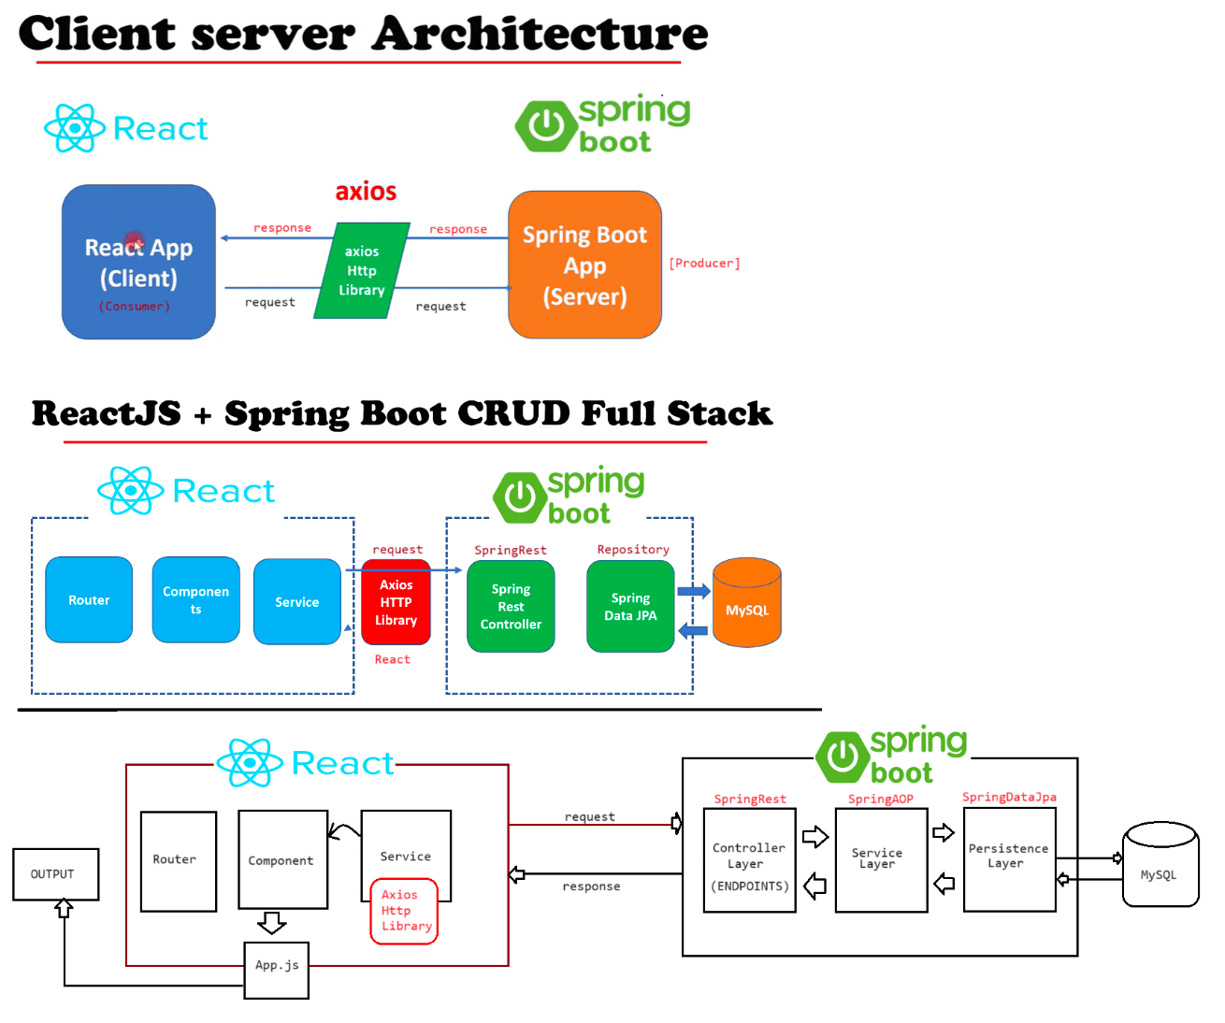
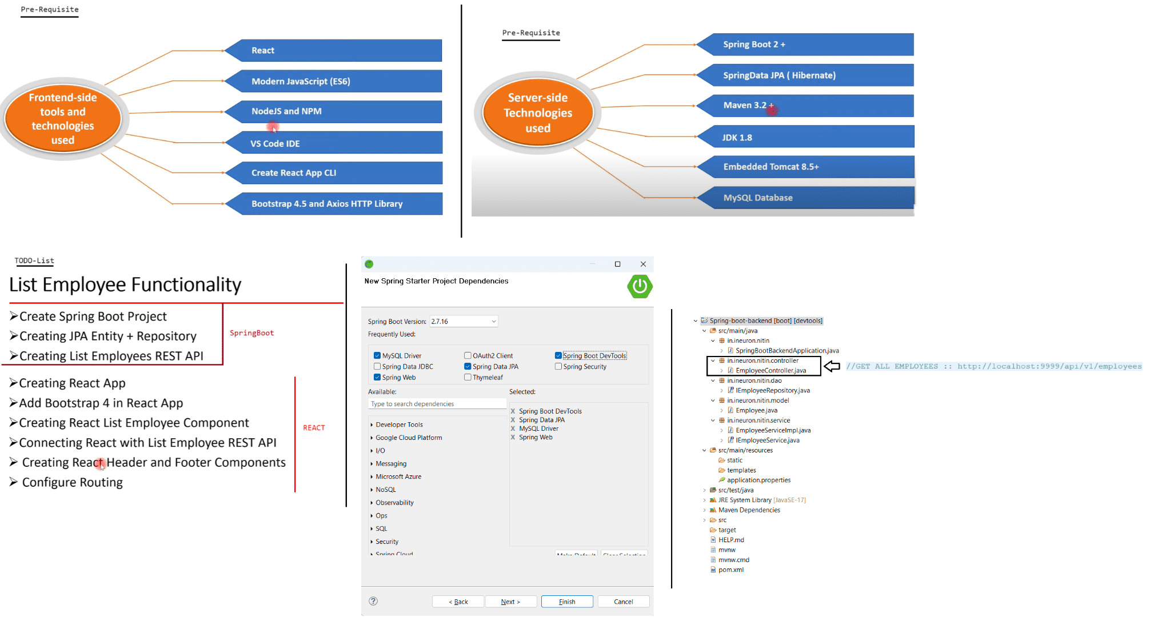
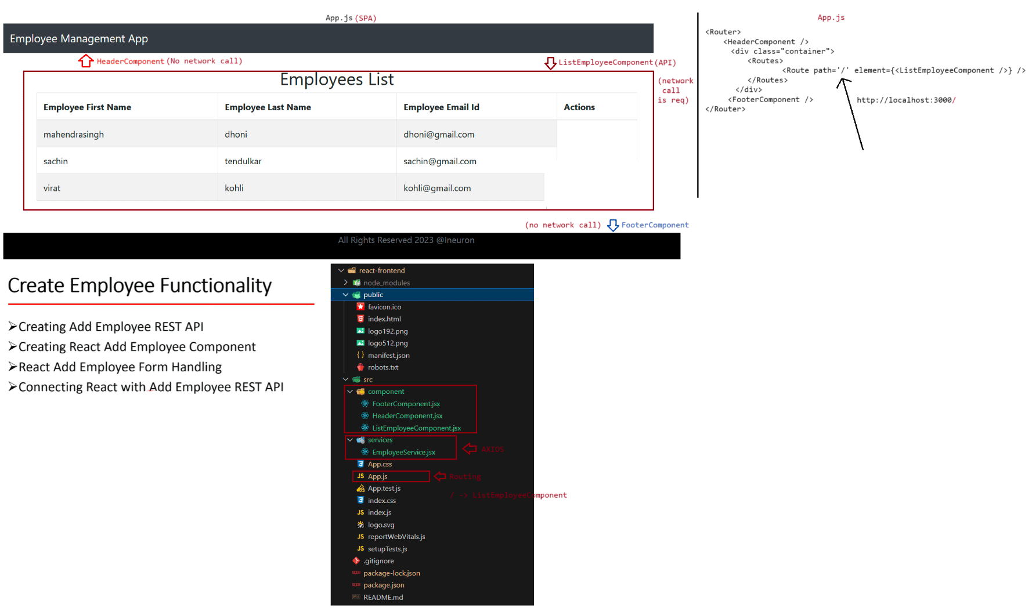

236 SpringRest with React, Connection pooling of server(tomcat), Types of driver of JDBC Live Class

Create Employee Functionality
a. ENDPOINTS : POST -> http://localhost:9999/api/v1/employees
React
+++++
1. Create a button in ListEmployeeComponent to perform Insert operation
ListEmployeeComponent.jsx
+++++++++++++++++++++++++
import React, { useState,useEffect } from 'react';
import {getEmployees} from "../services/EmployeeService"
import { useNavigate } from 'react-router-dom';
function ListEmployeeComponent() {
//employees <----setEmployees()
const [employees, setEmployees] = useState([]);
const navigate = useNavigate();
useEffect(() => {
//Calling API From BackEnd to get the data of Employees
getEmployees().then((emp) => {
//Inject data to employees varaible
setEmployees(emp.data);
});
}, []);
//navigation to the respective component
const addEmployee =()=> {
navigate("/add-employee")
}
return (
<div className="m-4">
<h2 className="text-center">Employees List</h2>
<!-- CREATING AN ADD BUTTON TO ADD EMPLOYEE RECORD -->
<div className = "row">
<button className='btn btn-primary' onClick={addEmployee}>ADD
EMPLOYEE</button>
</div><br/>
<div className="row">
<table className="table table-striped table-bordered">
<thead>
<tr>
<th> Employee First Name</th>
<th> Employee Last Name</th>
<th> Employee Email Id</th>
<th> Actions</th>
</tr>
</thead>
<tbody>
{employees.map((employee) => (
<tr key={employee.id}><td> {employee.firstName}</td>
<td> {employee.lastName}</td>
<td> {employee.emailId}</td>
</tr>
))}
</tbody>
</table>
</div>
</div>
);
}
export default ListEmployeeComponent;
+++++++++++++++++++++++++++++++++++++++++++++++++++++++++++++++++++++++++++++++++++
+++++++
Configure Routing in App.js page
++++++++++++++++++++++++++++++++
import ListEmployeeComponent from './component/ListEmployeeComponent';
import HeaderComponent from './component/HeaderComponent';
import FooterComponent from './component/FooterComponent';
import { BrowserRouter as Router } from 'react-router-dom';
import { Routes, Route } from "react-router";
import 'bootstrap/dist/css/bootstrap.min.css'
import './App.css';
import CreateEmployeeComponent from './component/CreateEmployeeComponent';
function App() {
return (
<div>
<Router>
<HeaderComponent />
<div class="container">
<Routes>
<Route path='/' element={<ListEmployeeComponent />} />
<Route path='/employees' element={<ListEmployeeComponent />} />
<!-- Configured Routing to route for /add-employee which display
insert record page --->
<Route path='/add-employee' element={<CreateEmployeeComponent />}
/>
</Routes>
</div>
<FooterComponent />
</Router>
</div>
);
}
export default App;
+++++++++++++++++++++++++++++++++++++++++++++++++++++++++++++++++++++++++++++++++++
Create a Component called CreateEmployeeComponent in src folder
+++++++++++++++++++++++++++
CreateEmployeeComponent.jsx
+++++++++++++++++++++++++++import React, { useState } from 'react';
import { useNavigate } from 'react-router-dom';
function CreateEmployeeComponent() {
//React hook which will be used to render the page
const [employee, setEmployee] = useState({
firstName: '',
lastName: '',
emailId: ''
});
const navigate = useNavigate()
const changeFirstNameHandler = (event) => {
setEmployee({ ...employee, firstName: event.target.value });
}
const changeLastNameHandler = (event) => {
setEmployee({ ...employee, lastName: event.target.value });
}
const changeEmailHandler = (event) => {
setEmployee({ ...employee, emailId: event.target.value });
}
//Performing necessary actions
const saveOrUpdateEmployee = (e) => {
//Display the output values on the console to check whether it is coming or not
e.preventDefault();
console.log('employee => ' + JSON.stringify(employee));
//Performing necessary actions
const cancel = () => {
navigate("/")
}
}
return (
<div>
<br></br>
<div className="container">
<div className="row">
<div className="card col-md-6 offset-md-3 offset-md-3">
<h3 className="text-center">Add Employee</h3>
<div className="card-body">
<form>
<div className="form-group">
<label> First Name: </label>
<input placeholder="First Name" name="firstName" className="form-
control"
value={employee.firstName} onChange={changeFirstNameHandler} />
</div>
<div className="form-group">
<label> Last Name: </label>
<input placeholder="Last Name" name="lastName" className="form-
control"value={employee.lastName} onChange={changeLastNameHandler} />
</div>
<div className="form-group">
<label> Email Id: </label>
<input placeholder="Email Address" name="emailId"
className="form-control"
value={employee.emailId} onChange={changeEmailHandler} />
</div>
<button className="btn btn-success"
onClick={saveOrUpdateEmployee}>Save</button>
<button className="btn btn-danger" onClick={cancel}
style={{ marginLeft: "10px" }}>Cancel</button>
</form>
</div>
</div>
</div>
</div>
</div>
);
}
export default CreateEmployeeComponent;
+++++++++++++++++++++++++++++++++++++++++++++++++++++++++++++++++++++++++++++++++++
+++++++++++
Upon clicking on ADD EMPLOYEE -> CreateEmploye Component page will be available
upon entering the details and clicking on save ---> it should make a call to
ENDPOINTS : POST -> http://localhost:9999/api/v1/employees
Create a new Service in ServiceComponent.jsx
++++++++++++++++++++++++++++++++++++++++++++
import axios from 'axios';
const EMPLOYEE_API_BASE_URL = "http://localhost:9999/api/v1/employees";
export const getEmployees = () => {
return axios.get(EMPLOYEE_API_BASE_URL);
};
export const createEmployee = (employee) => {
return axios.post(EMPLOYEE_API_BASE_URL, employee);
};
+++++++++++++++++++++++++++++++++++++++++++++++++++++++++++++++
CreateEmployeeComponent.jsx
+++++++++++++++++++++++++++
import React, { useState } from 'react';
import { useNavigate } from 'react-router-dom';
import { createEmployee } from '../services/EmployeeService';
function CreateEmployeeComponent() {
//React hook which will be used to render the page
const [employee, setEmployee] = useState({
firstName: '',lastName: '',
emailId: ''
});
const navigate = useNavigate()
const changeFirstNameHandler = (event) => {
setEmployee({ ...employee, firstName: event.target.value });
}
const changeLastNameHandler = (event) => {
setEmployee({ ...employee, lastName: event.target.value });
}
const changeEmailHandler = (event) => {
setEmployee({ ...employee, emailId: event.target.value });
}
const saveOrUpdateEmployee = (e) => {
//Display the output values on the console to check whether it is coming or not
e.preventDefault();
console.log('employee => ' + JSON.stringify(employee));
//Actual code which will call the services from backend and re-direct to main
page
createEmployee(employee).then((res) => {
navigate('/employees'); // Use navigate
});
const cancel = () => {
navigate("/")
}
}
return (
<div>
<br></br>
<div className="container">
<div className="row">
<div className="card col-md-6 offset-md-3 offset-md-3">
<h3 className="text-center">Add Employee</h3>
<div className="card-body">
<form>
<div className="form-group">
<label> First Name: </label>
<input placeholder="First Name" name="firstName" className="form-
control"
value={employee.firstName} onChange={changeFirstNameHandler} />
</div>
<div className="form-group">
<label> Last Name: </label>
<input placeholder="Last Name" name="lastName" className="form-
control"
value={employee.lastName} onChange={changeLastNameHandler} />
</div>
<div className="form-group">
<label> Email Id: </label>
<input placeholder="Email Address" name="emailId"
className="form-control"value={employee.emailId} onChange={changeEmailHandler} />
</div>
<button className="btn btn-success"
onClick={saveOrUpdateEmployee}>Save</button>
<button className="btn btn-danger" onClick={cancel}
style={{ marginLeft: "10px" }}>Cancel</button>
</form>
</div>
</div>
</div>
</div>
</div>
);
}
export default CreateEmployeeComponent;
+++++++++++++++++++++++++++++++++++++++++++OUTPUT DISPLAYED(ListEmployeeComponent)+
++++++++++++++++++++++++++++++++++++++++++++++++++++++++
Working with Update Module
++++++++++++++++++++++++++
1. Create a ENDPOINT to get the record based on id value
GET :: http://localhost:9999/api/v1/employees/{id}
2. Create a React code to send the request to the page
a. Update ListEmployeeComponent.jsx with UPDATE Button
import React, { useState,useEffect } from 'react';
import {getEmployees} from "../services/EmployeeService"
import { useNavigate } from 'react-router-dom';
function ListEmployeeComponent() {
//employees <----setEmployees()
const [employees, setEmployees] = useState([]);
const navigate = useNavigate();
useEffect(() => {
//Calling API From BackEnd to get the data of Employees
getEmployees().then((emp) => {
//Inject data to employees varaible
setEmployees(emp.data);
});
}, []);
const addEmployee =()=> {
navigate("/add-employee")
}
//COLLECTED THE DYNAMIC VALUE BASED ON THE USER INTERACTION
const editEmployee = (id) => {
console.log("id:: " + id);
//USE ROUTER TO ROUTE TO /update-employee/${id} ----> UpdateEmployeeComponentnavigate(`/update-employee/${id}`);
};
return (
<div className="m-4">
<h2 className="text-center">Employees List</h2>
<div className = "row">
<button className='btn btn-primary' onClick={addEmployee}>ADD
EMPLOYEE</button>
</div><br/>
<div className="row">
<table className="table table-striped table-bordered">
<thead>
<tr>
<th> Employee First Name</th>
<th> Employee Last Name</th>
<th> Employee Email Id</th>
<th> Actions</th>
</tr>
</thead>
<tbody>
{employees.map((employee) => (
<tr key={employee.id}>
<td> {employee.firstName}</td>
<td> {employee.lastName}</td>
<td> {employee.emailId}</td>
<!-- CREATING A BUTTON FOR UPDATE --!>
<button onClick={() => editEmployee(employee.id)} className="btn
btn-info">Update</button>
</tr>
))}
</tbody>
</table>
</div>
</div>
);
}
export default ListEmployeeComponent;
+++++++++++++++++++++++++++++++++++++++++++++++++++++++++++++++++++++++++++++++++++
++++
Create an UpdateEmployeeComponent.jsx in src folder
import React, { useState, useEffect } from 'react';
import { useParams, useNavigate } from 'react-router-dom';
import { getEmployeeById, updateEmployee } from '../services/EmployeeService';
function UpdateEmployeeComponent() {
const navigate = useNavigate()
const { id } = useParams();
const [employee, setEmployee] = useState({
id: id,
firstName: '',
lastName: '',emailId: ''
value
});
useEffect(() => {
const fetchEmployee = async () => {
try {
//Calling the Backend api to load the data to the page based on id
const response = await getEmployeeById(id);
const employeeData = response.data;
setEmployee({
id: id,
firstName: employeeData.firstName,
lastName: employeeData.lastName,
emailId: employeeData.emailId,
});
} catch (error) {
console.error(error);
}
};
fetchEmployee();
}, [id]);
const updateEmployeeData = async (e) => {
e.preventDefault();
console.log(employee)
};
const changeFirstNameHandler = (event) => {
setEmployee({ ...employee, firstName: event.target.value });
const changeLastNameHandler = (event) => {
setEmployee({ ...employee, lastName: event.target.value });
const changeEmailHandler = (event) => {
setEmployee({ ...employee, emailId: event.target.value });
}
}
}
const changeHandler = (event) => {
setEmployee({
...employee,
[event.target.name]: event.target.value,
});
};
const cancel = () => {
navigate("/")
}
return (
<div>
<br></br>
<div className="container"><div className="row">
<div className="card col-md-6 offset-md-3 offset-md-3">
<h3 className="text-center">Update Employee</h3>
<div className="card-body">
<form>
<div className="form-group">
<label> First Name: </label>
<input placeholder="First Name"
name="firstName" className="form-control"
value={employee.firstName}
onChange={changeFirstNameHandler} />
</div>
<div className="form-group">
<label> Last Name: </label>
<input placeholder="Last Name" name="lastName"
className="form-control"
value={employee.lastName}
onChange={changeLastNameHandler} />
name="emailId" className="form-control"
onChange={changeEmailHandler} />
</div>
<div className="form-group">
<label> Email Id: </label>
<input placeholder="Email Address"
value={employee.emailId}
</div>
<button className="btn btn-success"
onClick={updateEmployeeData}>update</button>
<button className="btn btn-danger" onClick={cancel}
style={{ marginLeft: "10px" }}>Cancel</button>
</form>
</div>
</div>
</div>
</div>
</div>
);
}
export default UpdateEmployeeComponent;
++++++++++++++++++++++++++++++++++++++++++++++++++++++++++++++++++++++++++++++++++
Create a Routing to /update-employee/{id} in App.js
App.js
+++++
import ListEmployeeComponent from './component/ListEmployeeComponent';
import HeaderComponent from './component/HeaderComponent';
import FooterComponent from './component/FooterComponent';
import { BrowserRouter as Router } from 'react-router-dom';
import { Routes, Route } from "react-router";
import 'bootstrap/dist/css/bootstrap.min.css'
import './App.css';
import CreateEmployeeComponent from './component/CreateEmployeeComponent';
import UpdateEmployeeComponent from './component/UpdateEmployeeComponent';function App() {
return (
<div>
<Router>
<HeaderComponent />
<div class="container">
<Routes>
<Route path='/' element={<ListEmployeeComponent />} />
<Route path='/employees' element={<ListEmployeeComponent />} />
<Route path='/add-employee' element={<CreateEmployeeComponent />}
/>
<!-- ROUTING FOR UPDATING THE RECORD --!>
<Route path='/update-employee/:id' element={<
UpdateEmployeeComponent/>} />
</Routes>
</div>
<FooterComponent />
</Router>
</div>
);
}
export default App;
++++++++++++++++++++++++++++++++++++Page rendered based on the id value selected by
the user ++++++++++++++++++++++++++++++++++++++++++++++++
=> User can make changes to the data present in the text box.
=> Upon clicking the save button respective changes should be made in the database
by making a call to backend.
Update END POINT :: PUT -> http://localhost:9999/api/v1/employees/{id}
App.js
+++++++
import axios from 'axios';
const EMPLOYEE_API_BASE_URL = "http://localhost:9999/api/v1/employees";
export const getEmployees = () => {
return axios.get(EMPLOYEE_API_BASE_URL);
};
export const createEmployee = (employee) => {
return axios.post(EMPLOYEE_API_BASE_URL, employee);
};
export function getEmployeeById(employeeId) {
return axios.get(`${EMPLOYEE_API_BASE_URL}/${employeeId}`);
}
export function updateEmployee(employee, employeeId) {
return axios.put(`${EMPLOYEE_API_BASE_URL}/${employeeId}`, employee);
}
++++++++
UpdateEmployeeComponent.jsx
+++++++++++++++++++++++++++++++++++++++++++++++++++++++++++++++++++++++++++++++++++
import React, { useState, useEffect } from 'react';import { useParams, useNavigate } from 'react-router-dom';
import { getEmployeeById,updateEmployee} from '../services/EmployeeService';
function UpdateEmployeeComponent() {
const navigate = useNavigate()
const { id } = useParams();
const [employee, setEmployee] = useState({
id: id,
firstName: '',
lastName: '',
emailId: ''
value
});
useEffect(() => {
const fetchEmployee = async () => {
try {
//Calling the Backend api to load the data to the page based on id
const response = await getEmployeeById(id);
const employeeData = response.data;
setEmployee({
id: id,
firstName: employeeData.firstName,
lastName: employeeData.lastName,
emailId: employeeData.emailId,
});
} catch (error) {
console.error(error);
}
};
}, [id]);
fetchEmployee();
const updateEmployeeData = async (e) => {
e.preventDefault();
console.log(employee)
//Calling API to send the data to BackEnd to perform update operation
await updateEmployee(employee, id);
navigate('/employees');
};
const changeFirstNameHandler = (event) => {
setEmployee({ ...employee, firstName: event.target.value });
const changeLastNameHandler = (event) => {
setEmployee({ ...employee, lastName: event.target.value });
const changeEmailHandler = (event) => {
setEmployee({ ...employee, emailId: event.target.value });
}
}
}const changeHandler = (event) => {
setEmployee({
...employee,
[event.target.name]: event.target.value,
});
};
const cancel = () => {
navigate("/")
}
return (
<div>
<br></br>
<div className="container">
<div className="row">
<div className="card col-md-6 offset-md-3 offset-md-3">
<h3 className="text-center">Update Employee</h3>
<div className="card-body">
<form>
<div className="form-group">
<label> First Name: </label>
<input placeholder="First Name"
name="firstName" className="form-control"
value={employee.firstName}
onChange={changeFirstNameHandler} />
</div>
<div className="form-group">
<label> Last Name: </label>
<input placeholder="Last Name" name="lastName"
className="form-control"
value={employee.lastName}
onChange={changeLastNameHandler} />
</div>
<div className="form-group">
<label> Email Id: </label>
<input placeholder="Email Address"
name="emailId" className="form-control"
value={employee.emailId}
onChange={changeEmailHandler} />
</div>
<button className="btn btn-success"
onClick={updateEmployeeData}>update</button>
<button className="btn btn-danger" onClick={cancel}
style={{ marginLeft: "10px" }}>Cancel</button>
</form>
</div>
</div>
</div>
</div>
</div>
);
}
export default UpdateEmployeeComponent;+++++++++++++++++++++++++++++++++++++++++++++++++++++++++++++++++++++++++++++++++++
++++++++++++++++++++++++++++
Delete record based on the id value
+++++++++++++++++++++++++++++++++++
1. Create an ENDPOINT
DELETE: http://localhost:9999/api/v1/employees/{id}
2. React
a. Create a button called delete in ListEmployeeComponent.jsx
import React, { useState,useEffect } from 'react';
import {getEmployees} from "../services/EmployeeService"
import { useNavigate } from 'react-router-dom';
function ListEmployeeComponent() {
//employees <----setEmployees()
const [employees, setEmployees] = useState([]);
const navigate = useNavigate();
useEffect(() => {
//Calling API From BackEnd to get the data of Employees
getEmployees().then((emp) => {
//Inject data to employees varaible
setEmployees(emp.data);
});
}, []);
const addEmployee =()=> {
navigate("/add-employee")
}
const editEmployee = (id) => {
console.log("id:: " + id);
navigate(`/update-employee/${id}`);
};
//logic for deletion to happen upon the click
const deleteEmployee = (id) => {
console.log("id:: " + id);
};
return (
<div className="m-4">
<h2 className="text-center">Employees List</h2>
<div className = "row">
<button className='btn btn-primary' onClick={addEmployee}>ADD
EMPLOYEE</button>
</div><br/>
<div className="row">
<table className="table table-striped table-bordered">
<thead><tr>
<th> Employee First Name</th>
<th> Employee Last Name</th>
<th> Employee Email Id</th>
<th> Actions</th>
</tr>
</thead>
<tbody>
{employees.map((employee) => (
<tr key={employee.id}>
<td> {employee.firstName}</td>
<td> {employee.lastName}</td>
<td> {employee.emailId}</td>
<button onClick={() => editEmployee(employee.id)} className="btn
btn-info">Update</button>
<!-- DELETE BUTTON ---- !>
<button onClick={() => deleteEmployee(employee.id)} className="btn
btn-danger ml-2">Delete</button>
</tr>
))}
</tbody>
</table>
</div>
</div>
);
}
export default ListEmployeeComponent;
+++++++++++++++++++++++++++++++++++++++++++++++++++++++++++++++++++++++++++++++++++
++++++
b. Add the services for delete in EmployeeService.jsx
import axios from 'axios';
const EMPLOYEE_API_BASE_URL = "http://localhost:9999/api/v1/employees";
export const getEmployees = () => {
return axios.get(EMPLOYEE_API_BASE_URL);
};
export const createEmployee = (employee) => {
return axios.post(EMPLOYEE_API_BASE_URL, employee);
};
export function getEmployeeById(employeeId) {
return axios.get(`${EMPLOYEE_API_BASE_URL}/${employeeId}`);
}
export function updateEmployee(employee, employeeId) {
return axios.put(`${EMPLOYEE_API_BASE_URL}/${employeeId}`, employee);
}
export function deleteEmployeeById(employeeId) {
return axios.delete(`${EMPLOYEE_API_BASE_URL}/${employeeId}`);
}
c. Make the changes in ListEmployeeComponent.jsx to delete the record based on idvalue
import React, { useState,useEffect } from 'react';
import {getEmployees,deleteEmployeeById} from "../services/EmployeeService"
import { useNavigate } from 'react-router-dom';
function ListEmployeeComponent() {
//employees <----setEmployees()
const [employees, setEmployees] = useState([]);
const navigate = useNavigate();
useEffect(() => {
//Calling API From BackEnd to get the data of Employees
getEmployees().then((emp) => {
//Inject data to employees varaible
setEmployees(emp.data);
});
}, []);
const addEmployee =()=> {
navigate("/add-employee")
}
const editEmployee = (id) => {
console.log("id:: " + id);
navigate(`/update-employee/${id}`);
};
const deleteEmployee = (id) => {
console.log("id:: " + id);
//Make a call to backend to delete the record
deleteEmployeeById(id).then((res) => {
//display the same page with the record not matching with the supplied id
setEmployees(employees.filter((employee) => employee.id !== id));
value
});
};
return (
<div className="m-4">
<h2 className="text-center">Employees List</h2>
<div className = "row">
<button className='btn btn-primary' onClick={addEmployee}>ADD
EMPLOYEE</button>
</div><br/>
<div className="row">
<table className="table table-striped table-bordered">
<thead>
<tr>
<th> Employee First Name</th>
<th> Employee Last Name</th>
<th> Employee Email Id</th>
<th> Actions</th></tr>
</thead>
<tbody>
{employees.map((employee) => (
<tr key={employee.id}>
<td> {employee.firstName}</td>
<td> {employee.lastName}</td>
<td> {employee.emailId}</td>
<button onClick={() => editEmployee(employee.id)} className="btn
btn-info">Update</button>
btn-danger ml-2">Delete</button>
<button onClick={() => deleteEmployee(employee.id)} className="btn
</tr>
))}
</tbody>
</table>
</div>
</div>
);
}
export default ListEmployeeComponent;
++++++++++++++++++++++++++++++++++Fully Functional Code is Ready+++++++++++++++++++
++++++++++++++++++++++++++++++++++++++++++++++++++
Server Managed Connection Pool
++++++++++++++++++++++++++++++
Connection Pooling Management(CPM)
=> It is a new way of organising connection objects in JavaEE environment.
=> Connection Pooling manager is a software component and it is a part of server
and it manages connection objects.
=> Here the connection objects are reusable.
To configure connection pool, use the following
a. Open the browser
b. Open google
c. Type the following in search bar(tomcat resource tag)
d. Click on the following link
https://tomcat.apache.org/tomcat-9.0-doc/jndi-resources-howto.html
e. Click on JDBC datasources hyperlink
f. Copy Resource tag
<Resource name="jdbc/EmployeeDB"
auth="Container"
type="javax.sql.DataSource"
username="dbusername"
password="dbpassword"
driverClassName="org.hsql.jdbcDriver"
url="jdbc:HypersonicSQL:database"
maxTotal="8"
maxIdle="4"/>
g. Copied text paste in context.xml file between <Context> tags.
In eclipse environment goto servers folder
open context.xml and paste the above code inside <context> tag.h. Change the following fields as per the db usage in project
<Resource name="jdbc/EmployeeDB"
auth="Container"
type="javax.sql.DataSource"
username="root"
password="root123"
driverClassName="com.mysql.cj.jdbc.Driver"
url="jdbc:mysql://localhost:3306/octbatch"
maxTotal="8"
maxIdle="4"/>
i. Access this connection pool in Servlet code.
// Obtain our environment naming context
Context initCtx = new InitialContext();
Context envCtx = (Context) initCtx.lookup("java:comp/env");
// Look up our data source
DataSource ds = (DataSource)envCtx.lookup("jdbc/EmployeeDB");
// Allocate and use a connection from the pool
Connection conn = ds.getConnection();
//use connection object to perform neccessary persistence operation
conn.......
//use this connection to access the database ...
conn.close();
++++++++++++++++++++++++++++++Demonstrating the connection pool of server using
JNDI ********************************
context.xml
+++++++++++
<Context>
<Resource name="jndi"
auth="Container"
type="javax.sql.DataSource"
username="root"
password="root123"
driverClassName="com.mysql.cj.jdbc.Driver"
url="jdbc:mysql://localhost:3306/octbatch"
maxTotal="8"
maxIdle="4"/>
<!-- Default set of monitored resources. If one of these changes, the <!-- web application will be reloaded. <WatchedResource>WEB-INF/web.xml</WatchedResource>
<WatchedResource>WEB-INF/tomcat-web.xml</WatchedResource>
<WatchedResource>${catalina.base}/conf/web.xml</WatchedResource>
-->
-->
<!-- Uncomment this to disable session persistence across Tomcat restarts -->
<!--
-->
</Context>
<Manager pathname="" />TestServlet.java
++++++++++++++++
package in.ineuron.nitin.controller;
import java.io.IOException;
import java.io.PrintWriter;
import java.sql.Connection;
import java.sql.SQLException;
import javax.naming.Context;
import javax.naming.InitialContext;
import javax.naming.NamingException;
import javax.servlet.ServletException;
import javax.servlet.http.HttpServlet;
import javax.servlet.http.HttpServletRequest;
import javax.servlet.http.HttpServletResponse;
import javax.sql.DataSource;
public class TestServlet extends HttpServlet {
private static final long serialVersionUID = 1L;
@Override
protected void doGet(HttpServletRequest request, HttpServletResponse
response) throws ServletException, IOException {
try {
"+conn+"</h1>");
}
Context initCtx = new InitialContext();
Context envCtx = (Context) initCtx.lookup("java:comp/env");
//Looking for JNDI registry with the name called "jndi"
DataSource ds = (DataSource)envCtx.lookup("jndi");
Connection conn = ds.getConnection();
PrintWriter out = response.getWriter();
out.println("<h1>Connection poool of server is ::
out.close();
} catch (NamingException | SQLException e) {
e.printStackTrace();
}
}
request :http://localhost:8888/ConnectionPool-01/test
response :Connection poool of server is :: 1752069992,
URL=jdbc:mysql://localhost:3306/octbatch, MySQL Connector/J
JNDI
+++
=> It stands for Java Naming Directory Interface
=> It is an API/technology available in jdksoftware that is given to interact with
JNDI registery software.
=> Inside this JNDIRegistry we keep the datasource object reference.
=> JNDI Registry is given from server eniroment to keep the reference of
datasource object which is available for every component in webapplication.
refer: diagram+++++++++++++++++++++++
JDBC Driver information
+++++++++++++++++++++++
Types of Drivers
While communicating with Database, we have to convert Java Calls into Database
specific Calls and Database specific Calls into Java Calls.
For this Driver Software is required. In the Ma
rket Thousands of Driver Softwares are available.
But based on Functionality all Driver Software Drivers are divided into 4 Types.
1) Type-1 Driver (JDBC-ODBC Bridge Driver OR Bridge Driver)
2) Type-2 Driver (Native API-Partly Java Driver OR Native Driver)
3) Type-3 Driver (All Java Net Protocol Driver OR Network Protocol Driver OR
Middleware Driver)
4) Type-4 Driver (All Java Native Protocol Driver OR Pure Java Driver OR Thin
Driver)
This Driver provided by Sun Micro Systems as the Part of JDK. But this Support is
available until 1.7 Version only.
Internally this Driver will take Support of ODBC Driver to communicate with
Database.
Type-1 Driver converts JDBC Calls (Java Calls) into ODBC Calls and ODBC Driver
converts ODBC Calls into Database specific Calls.
Hence Type-1 Driver acts as Bridge between JDBC and ODBC.
Advantages :
1. It is very easy to use and maintain.
2. We are not required to install any separate Software because it is available as
the Part of JDK.
3. Type-1 Driver won't communicates directly with the Database. Hence it is
Database Independent Driver. Because of this migrating from
one Database to another Database will become Easy.
Limitations:
1. It is the slowest Driver among all JDBC Drivers (Snail Driver), because first it
will convert JDBC Calls into ODBC Calls and ODBC Driver
converts ODBC Calls into Database specific Calls.
2. This Driver internally depends on ODBC Driver, which will work only on Windows
Machines. Hence Type-1 Driver is Platform Dependent Driver.
3. No Support from JDK 1.8 Version onwards.
Note:
Because of above Limitations it is never recommended to use Type-1 Driver.
+++++++++++++
Type-2 Driver
+++++++++++++
Type-2 Driver is exactly same as Type-1 Driver except that ODBC Driver is replaced
with Vendor specific Native Libraries.
Type-2 Driver internally uses Vendor specific Native Libraries to Communicate with
Database.
Native Libraries means the Set of Functions written in Non-Java (Mostly C OR C++).
We have to install Vendor provided Native Libraries on the Client Machine.
Type-2 Driver converts JDBC Calls into Vendor specific Native Library Calls, which
can be understandable directly by Database Engine.Advantages:
1. When compared with Type-1 Driver Performance is High, because it required only
one Level Conversion from JDBC to Native Library Calls.
2. No need of arranging ODBC Drivers.
3. When compared with Type-1 Driver, Portability is more because Type-1 Driver is
applicable only for Windows Machines.
Limitations:
1. Internally this Driver using Database specific Native Libraries and hence it is
Database Dependent Driver.
Because of this migrating from one Database to another Database will become
Difficult.
2. This Driver is Platform Dependent Driver.
3. On the Client Machine compulsory we should install Database specific Native
Libraries.
4. There is no Guarantee for every Database Vendor will provide This Driver.
(Oracle People provided Type-2 Driver but MySql People won't provide this Driver)
Eg: OCI (Oracle Call Interface) Driver is Type-2 Driver provided by Oracle.
OCI Driver internally uses OCI Libraries to communicate with Database.
OCI Libraries contain "C Language Functions"
OCI Driver and corresponding OCI Libraries are available in the following Jar File.
Hence we have to place this Jar File in the Class Path.
ojdbc14.jar Oracle 10g (Internally Uses Java 1.4V)➔
ojdbc6.jar Oracle 11g (Internally Uses Java 1.6V)➔
ojdbc7.jar Oracle 12c (Internally Uses Java 1.7V)➔
Note: The only Driver which is both Platform Dependent and Database Dependent is
Type-2 Driver. Hence it is not recommended to use Type-2 Driver.
++++++++++++
Type-3 Driver
+++++++++++++
Type-3 Driver converts JDBC Calls into Middleware Server specific Calls. Middleware
Server can convert Middleware Server specific Calls
into Database specific Calls.
Internally Middleware Server may use Type-1, 2 OR 4 Drivers to communicates with
Database.
Advantages:
1. This Driver won't communicate with Database directly and hence it is Database
Independent Driver.
2. This Driver is Platform Independent Driver.
3. No need of ODBC Driver OR Vendor specific Native Libraries.
Limitations:
1. Because of having Middleware Server in the Middle, there may be a chance of
Performance Problems.
2. We need to purchase Middleware Server and hence the cost of this Driver is more
when compared with remaining Drivers.
Eg: IDS Driver (Internet Database Access Server)
Note: The only Driver which is both Platform Independent and Database Independent
is Type-3 Driver. Hence it is recommended to use.
+++++++++++++
Type-4 Driver+++++++++++++
=> This Driver is developed to talk with the Database directly without taking
Support of ODBC Driver OR Vendor Specific Native Libraries
OR Middleware Server.
=> This Driver uses Database specific Native Protocols to communicate with the
Database.
=> This Driver converts JDBC Calls directly into Database specific Calls.
=> This Driver developed only in Java and hence it is also known as Pure Java
Driver. Because of this, Type-4 Driver is Platform Independent Driver.
=> This Driver won't require any Native Libraries at Client side and hence it is
light weighted. Because of this it is treated as Thin Driver.
Advantages:
1. It won't require any Native Libraries, ODBC Driver OR Middleware Server
2. It is Platform Independent Driver
3. It uses Database Vendor specific Native Protocol and hence Security is more.
Limitation:
The only Limitation of this Driver is, it is Database Dependent Driver because it
is communicating with the Database directly.
Eg: Thin Driver for Oracle, Connector/J Driver for MySQL
Note: It is highly recommended to use Type-4 Driver.
Java Application Type-1 Driver ODBC Driver DB➔ ➔ ➔
Java Application Type-2 Driver Vendor Specific Native Libraries DB➔ ➔ ➔
Java Application Type-3 Driver Middleware Server DB➔ ➔ ➔
Java Application Type-4 Driver DB➔ ➔
Which Driver should be used?
1. If we are using only one Type of Database in our Application then it is
recommended to use Type-4 Driver.
Eg: Stand Alone Applications, Small Scale Web Applications
2. If we are using multiple Databases in our Application then Type-3 Driver is
recommended to use.
Eg: Large Scale Web Applications and Enterprise Applications
3. If Type-3 and Type-4 Drivers are not available then only we should go for Type-2
Driver.
4. If no other Driver is available then only we should go for Type-1 Driver.

